**C A R E E R D E V E L O P M E N T E V E N T**

**POULTRY**

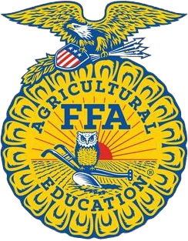**LOUISIANA FFA**

**Poultry Evaluation Career Development Event**

**Purpose:**

*Poultry evaluation is important to the producer as well as to the consumer. The producer must know how to select and produce good quality poultry and eggs and the consumer needs to know how to select the desired quality of meat and eggs.*

# Objectives:

1. To develop the students' abilities in the handling and evaluating live poultry, eggs, and processed poultry meat.
2. To develop the students' skills of observation, analysis, and communication.
3. To develop the students' knowledge of basic economic management skills for making sound decisions.
4. To develop the students' ability to analyze and select outstanding individual birds for production.
5. To develop the students' knowledge and awareness of the poultry industry.

# Event Format:

*Placing Classes:*

* 1. There may be two production classes of hens.
  2. There may be one class of ready to cook fryers, weighing between 2-6 pounds. Criteria for placing will be derived from the USDA standards relative poultry weight classes. *(Adopted 6/18)*

*Oral Reasons Ready-to-Cook*

*Eggs*

a. At least one set of oral reasons will be used

1. One class of 10 ready-to-cook broilers, fryers, or roasters to be graded according to quality.
2. One class of ready-to-cook turkeys may also be judged.
3. One class of 10 or less eggs may be judged for interior quality.
4. One class of 10 or less eggs may be judged for exterior quality.

*Broiler Parts ID*

* 1. One class of 10 broiler parts for identification. *Adopted 8/06*

# Rules and Regulations:

* 1. All general rules apply except as indicated by the specific rules for this event.

## Placing Class

a. Scantrons from the National FFA Poultry Evaluation contest will be

used.*(Adopted 6/18)*

1. All placing classes will consist of four birds of the same breed in each class.
2. The breeds used will be White Leghorns or a commercial strain of Leghorn type- in-bred cross.
3. The birds may or may not be de-beaked, de-combed or have one clipped wing.
4. The birds may be handled by the students as needed for placing classes.
5. Points will be deducted from a contestant's total score for handling the birds or the eggs incorrectly.
6. For area and state levels, the poultry contest rotation will consist of a 12 minute time limit for each part of the contest. (exterior eggs, interior eggs, hens, etc) (Adopted 6/23)

## Oral Reasons:

* 1. Contestant will have 12 minutes to place the class. At least 5 additional minutes will be given for preparing reasons.
  2. No more than 2 minutes will be allowed in delivering reasons.
  3. If a contestant uses notes of any kind (including placing cards) when delivering reasons, the contestant will be given a score of 5 or less points.
  4. Reasons will be scored on the basis of 50 points for a perfect score.
  5. University personnel will determine the class and number of classes for which reasons will be given.
  6. The reasons class or classes will be designated before the judging begins.
  7. On the area level, if oral reasons are not done as part of the rotation, and are done at the end, the 12 minute time limit will not pertain to oral reasons. (Adopted 6/23)
  8. On the state level, oral reasons will be part of the 12 minute rotation. After judging the live hen class, students will be given 12 minutes to prep their reasons and at the next 12 minute rotation, the students will recite their oral reasons. (Adopted 6/23)
  9. On all levels the 12 minute time limit can be extended by the contest superientendent if there are a large number of students who have not completed the rotation. (Adopted 6/23)

## Ready-to-Cook

a. Scantrons from the National FFA Poultry Evaluation contest will be

used.*(Adopted 6/18)*

1. The ready-to-cook class will consist of 10 birds - broilers, fryers, or roasters, 1/2 to 6 pounds in weight, to be graded according to quality.
2. Pinfeathers and filoplumes (hair) will not be considered in grading.
3. There may be one class of ready-to-cook turkeys (hens and/or toms) 8 to 14 pounds in weight.
4. See the latest revised edition of the USDA Handbook No. 31 "Poultry Grading Manual."
5. Ready to cook will be graded using the following: “A, B, C, No Grade. (Updated 2022)

## Interior Egg Quality.

a. Scantrons from the National FFA Poultry Evaluation contest will be

used.*(Adopted 6/18)*

1. There may be one class of 10 or fewer white or white-tint shell market eggs, to be graded for interior quality only.
2. Interior eggs will be graded using the following: “AA, A, B, Loss.” *Adopted 8/09*

## Exterior Egg Quality

a. Scantrons from the National FFA Poultry Evaluation contest will be

used.*(Adopted 6/18)*

1. There may be one class of 10 or fewer eggs which are to be graded for exterior quality only.
2. The eggs in the class to be graded for exterior quality only are not to be handled. They will be laid horizontally and decisions will be based on visible portions only.
3. All classes will be graded in accordance with the latest revised edition of the United States Standards for Shell Eggs. These standards and a chart illustrating standards of quality are from Poultry and Dairy Quality Division, FSQS, USDA,

D.C. 20250.

1. Exterior eggs will be graded in the following order: “A, B, or No Grade.” *Adopted 8/09 (Revised 6/18)*
2. Exterior eggs will be evaluated as the factors for the grading of the exterior chicken eggs. The written factors will relate to the criteria used for grading exterior quality of eggs. Criteria for grading will be derived from USDA standards for exterior quality of market eggs. The USDA quality grades will be AA/A, B and NG (nongradable). Criteria for grading may include decisions related to the following quality factors: Soundness (unbroken, check, dented check or leaker); stains (slight/moderate stain or prominent stain); adhering dirt or foreign material; egg shape (approximately normal shape, unusual or decidedly misshapen); shell texture (large calcium deposits, body check or pronounced ridges); shell thickness (pronounced thin spots); no defect.*(Adopted 6/18)*

## Broiler Parts Identification

* 1. One class of 10 broiler parts will be identified. *Adopted 8/09*
  2. Parts will be identified as they are listed in the Poultry Science Manual for National FFA CDE’s. *Adopted 8/09*

## Tie breakers: (apply in the following order)

* 1. Oral Reasons (event superintendent will select class if more than one reason class is used.)
  2. Placing class of production hens (Contest superintendent will select the class if there are two classes of production hens.)
  3. Contest superintendent will indicate other placing classes if needed for breaking ties.

**SCORE CARD FOR ORAL REASONS ON PULLETS AND ON PRODUCTION HENS**

1. DELIVERY AND APPEARANCE: (General neatness)

**Possible Contestant's Points Score**

|  |  |  |
| --- | --- | --- |
| A. Did contestant stand still on two feet and face the judges? | 2 |  |
| B. Did the contestant speak clearly, distinctly, and loud enough to be heard? | 2 |  |
| C. Did the contestant have an appropriate opening and closing sentence? | 2 |  |
| D. Did the contestant speak smoothly without long pauses? | 2 |  |
| E. Did the contestant have confidence? Was the contestant convincing? | 4 |  |

1. PROPER USE OF TERMS
   1. For production hens the contestant should place the most emphasis on:
      1. pigmentation and handling qualities
      2. width of back
      3. depth of body
      4. sexual maturity
      5. femininity

For production pullets, main concern is body depth, width of breast and across the hips, and length of heel. Normally, sexual maturity is not considered unless:

1. two birds are equal; then place the more sexually developed bird up.
2. sexual development should not be used to place a bird over another that is superior in body depth but lacking in sexual maturity. 5
   1. Did the contestant use the terms properly?

Did the contestant understand the terms used? Was the contestant able to define the terms?

(Contestant may be asked to define some comparative terms.) 5

TOTAL POINTS 10

1. ACCURACY OF STATEMENTS:
   1. Did the contestant really see the birds? 5
   2. Were the contestants, true, partly true, or false? 5

TOTAL POINTS 10

1. IMPORTANCE OF POINTS COVERED:
   1. Did contestant actually

|  |  |  |
| --- | --- | --- |
| tell why one bird was placed |  | |
| over another or did the contestant just vaguely describe the birds? | 5 |  |
| B. Did contestant stress crucial differences or make stereotype |  |  |
| comparisons of numerous factors? | 8 |  |
| C. Did the contestant tell all there was to tell of importance or were |  |  |
| there several good reasons that should have been given for placing? | 5 |  |
| TOTAL POINTS | 18 |  |

GRAND TOTAL POINTS 50

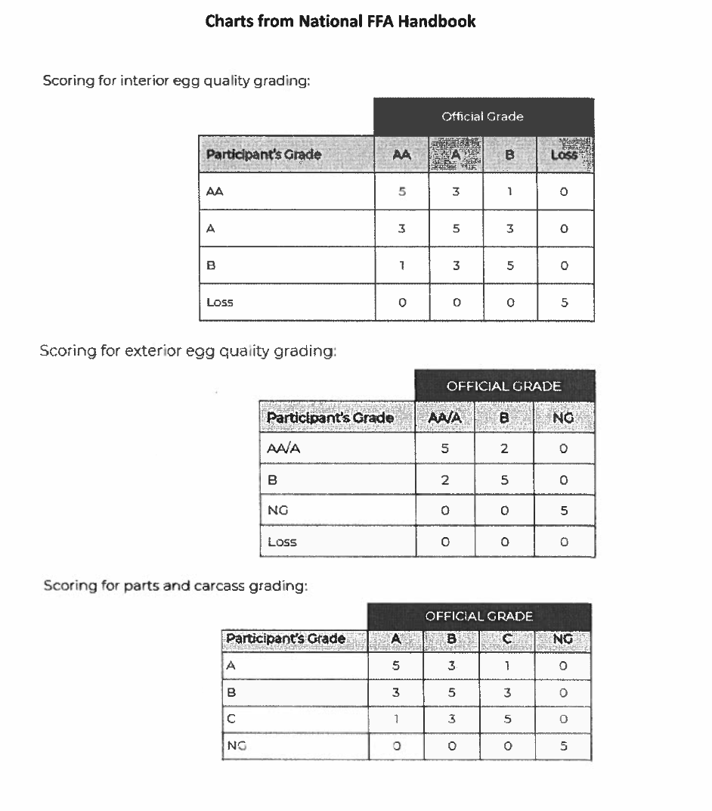

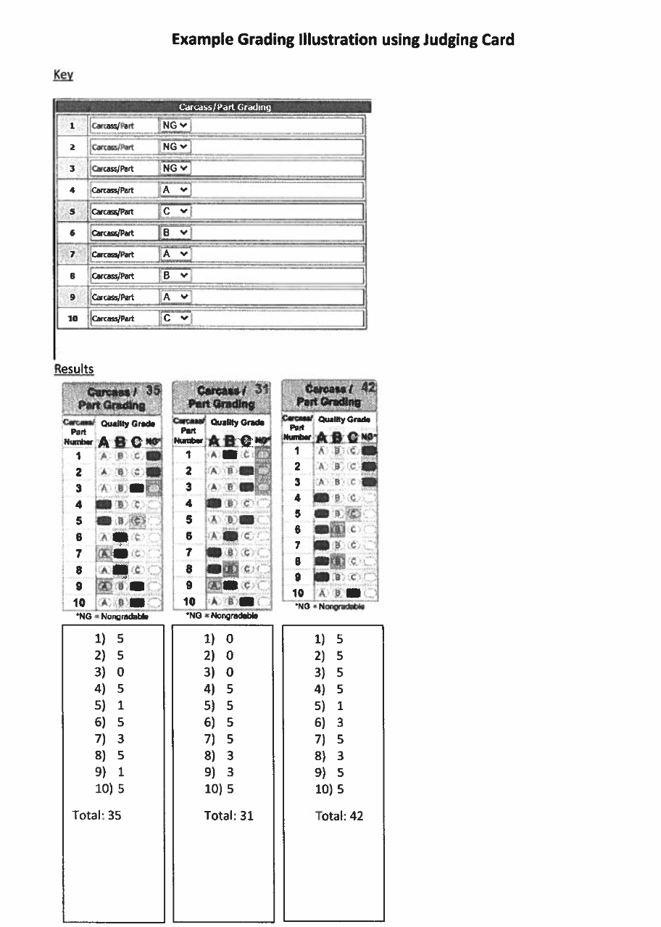

How to Give Reasons:

A poultry judge must have reasons for placing one bird over another. It is not enough just to "like" one bird more than another. You must know and be able to tell others why and where the bird you "like" excels the other birds in the class. Try to develop a mental picture of each class you judge. The time allowed to judge a class is usually 12 minutes. In this time, you must make your observations, record your placings, and take any notes you want on the outstanding good and bad points of each bird. You are allowed an additional 5 minutes to organize your thoughts and mentally prepare your reasons. Later on, you are generally allowed 2 minutes to give your oral reasons.

When you are called on to give your reasons:

1. Stand squarely on both feet. Stand 8 to 10 feet in front of the official judge, Look at the judge while you talk.
2. Speak clearly, distinctly, and loud enough to be heard. Do not make long pauses. Have confidence in what you are saying.
3. Use a definite system in giving reasons. Begin by giving your contestant identification number and by telling how you placed the class. Next tell why you placed the top bird first, then your second and third, and last tell why you have placed the bottom bird last.
4. Make sure that you have covered the most important points such as pigmentation, handling quality, abdominal capacity, molt, body size, degree of femininity, etc. Also make sure that your statements are accurate.
5. Make sure your reasons are well organized so that they emphasize the big differences. Be fair and impartial. Use more comparative than descriptive terms.
6. Never try to memorize one set of reasons and attempt to apply it to all classes judged. Use correct terms and be able to define the terms used. Do not use cattle terms for poultry. Also try not to use such terms as good, better or best in describing the birds; instead tell how or why one bird is good or better than another.
7. Don't repeat and back-track. Say everything you have to say about each bird and go on to the next.
8. Don't hunt for things to say. If you make up some points, they are sure to be wrong. If you forget, just go on to the next bird.