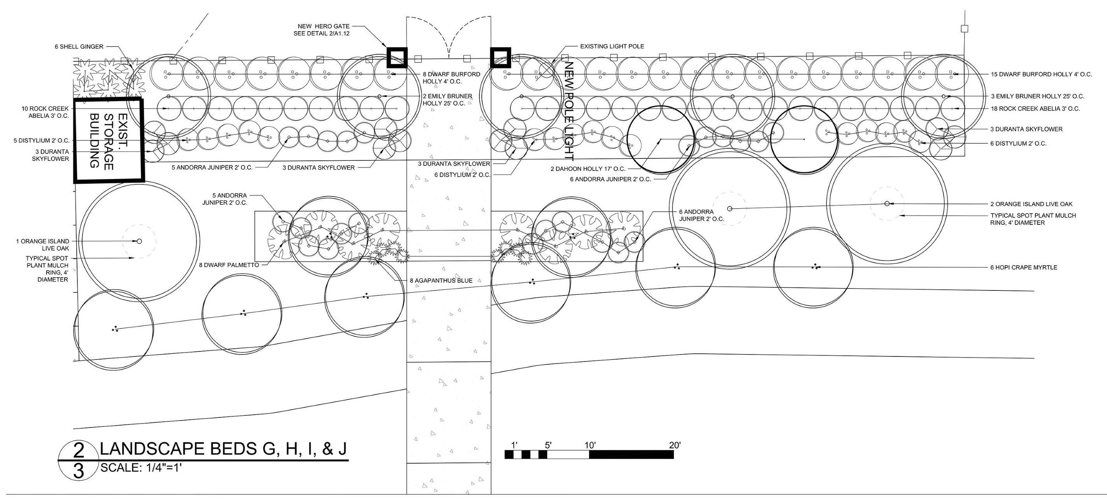
2025 State FFA Landscape Estimating Practicum


Scale: 1/2” = 5’

