**Area 3 Practicum 1**

1. What range is Caney lakes in?

A 10W

B 9W

C 20N

D 19N

E None of these

1. What do the highlighted numbers and symbols represent? (can be found on the Neatline at the bottom left of the map)

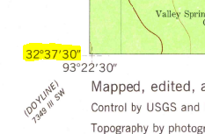

A latitude

B longitude

C graticule

D quadrangle

E none of these

1. How many acres are in ¼ of a section?

A 640

B 320

C 160

D 80

E 40

1. About how long is the Minden-Webster airport landing strip?
2. About ½ mile
3. About 1 mile
4. About 1.5 miles
5. About 2 miles
6. None of these
7. What is the elevation of the bridge that crosses cow creek in S1/2, S28, T20N, R9W

A 250

B 240

C 230

D 223

E 220

1. What can be found in SW1/4 of SW1/4, S17, T19N, R9W?

A substation

B radio tower

C Gilark

D Allen Cemetery

E None of these

1. What state highway runs north-south and lies about ½ of a mile due west of the boat ramp at Caney lakes?

A BR 180

B LA 3008

C LA 159

D LA 534

E None of these

1. What 3 things can be found in S1/2, S 33, T20N, R9W

A Picnic area, Sewage ponds, spillway

B Picnic area, boat ramp, campground

C Picnic area, houses, campground

D Cemetery, picnic area, campground

E Graves, campground, spillway

1. What national forest is found North of the town of Minden?

A Caney Lakes National Forest

B Kisatchie National Forest

C Bayou Dorcheat National Forest

D Minden-Webster national Forest

E None of these

1. How does the water run in these creeks when it rains (found in S17, T20N, R9W)
2. 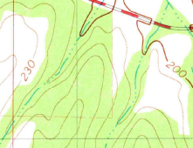
3. 
4. 

1B

2A

3C

4B

5D

6D

7B

8C

9B

10C