Practicum 2

1. The size of a chainsaw is determined by 2 things, they are:
2. Piston displacement and guide bar length
3. Chain length and engine power
4. Piston displacement and engine power
5. Engine power and guide bar length
6. Piston displacement and chain length
7. What process does this picture illustrate?

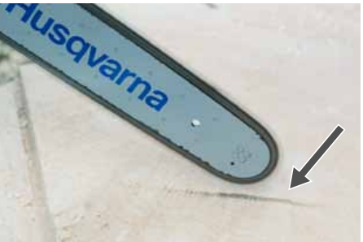

1. Cranking the engine
2. Warming up the engine
3. Checking the sharpness of the chain
4. Checking the bar lube system
5. Checking the spark plug
6. Choose the only true statement about this picture

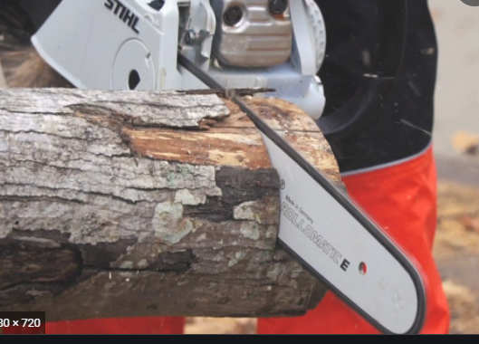

1. This cut is being made with a pushing chain
2. This cut is bring made with a pulling chain
3. This cut is in the kickback zone of the saw
4. This cut is considered a bore cut
5. This cut is making a humboldt notch
6. Identify the gullet

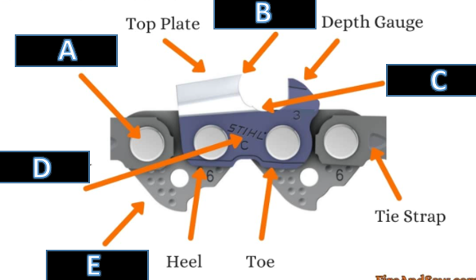

1. Identify the open face directional notch.

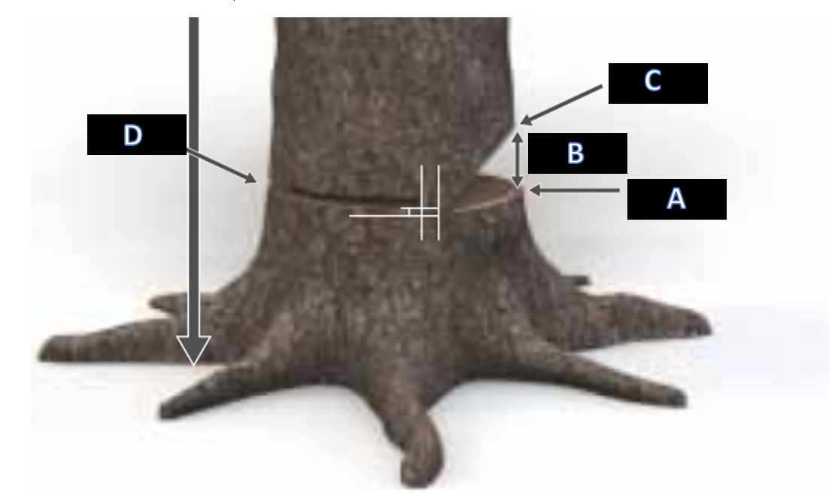

1. Pruning around the tree you are about to fell is very important but you should never prune above:
2. Ankle high
3. Knee high
4. Waist high
5. Shoulder high
6. Identify the compression side of this log.

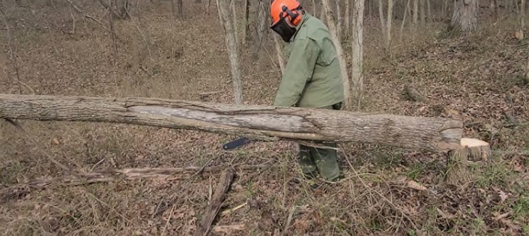

**A**

**C**

**B**

1. When limbing a tree that is fallen and resting knee high off the ground, what is the best practice for handling the saw:
2. You should never let the saw rest on the tree trunk, always hold the saws weight with your arms
3. You should rest the body of the saw on the trunk as much as possible
4. You should always stand on top of the tree, walk down it and handle the saw with both hands
5. You should get down on your knees and handle the saw with both hands
6. Identify the bar and chain oil reservoir cap.

A

B

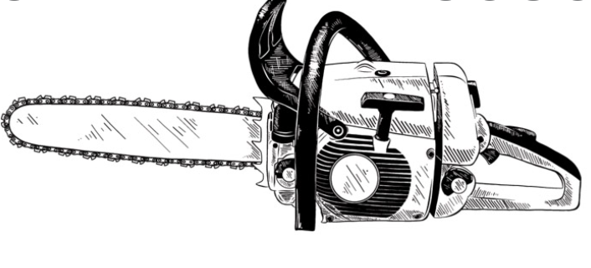

C

D

E

1. If you have an Oregon 91VG chain on your saw, what size file should you own?
2. 4.8/3/16
3. 5.5/7/32
4. 4.0/5/32
5. 5.5/7/32

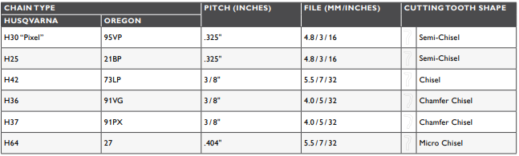

1 C

2 D

3 B

4 C

5 B

6 D

7A

8 B

9 E

10 C