Area 2 Practicum 1

1. What are the highlighted numbers and symbols found at a Neatline which can also be found in the top left hand corner of the map? 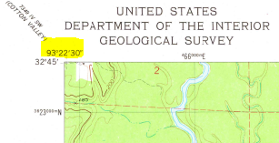

A Latitude

B Longitude

C Graticule

D Quadrangle

E None of these

1. What road class runs North-South through the middle of S7, T20N, R9W

A primary highway

B secondary highway

C light duty road

D unimproved road

E None of these

1. What is the number of that same road in S7 found in question number 2?

A 159

B 534

C 266

D 196

E 3008

1. How many sections constitute a township?

A 1

B 6

C 31

D 36

E None of these

1. What does the highlighted symbol represent in the context of map reading?

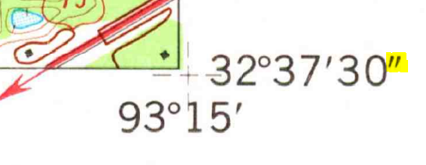

A Degrees B Minutes C Seconds D inches E feet

1. What is the elevation of the spillway in Caney Lakes at W1/2 of NE1/4, S5, T19N, R9W?

A 210

B 220

C 230

D 240

E None of these

1. What’s the highest point in elevation for S15, T20N, R9W

A 290

B 300

C 310

D 320

E None of these

1. What runs underneath the Minden-Webster Airport landing strip?

A underground telephone line

B underground powerline

C underground railroad

D underground pipeline

E None of these

1. About how many highway miles is it between the intersection of State Route 159/534 in the town of Minden and the New Hope Church in S26, T20N, R9W

A 3

B 3.5

C 4

D 4.5

E 5

1. How does the water flow in these creeks when it rains (found in NW1/4, S27, T20N, R9W)
2. 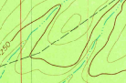
3. 
4. 

1B

2B

3E

4D

5C

6E

7C

8D

9D

10A