State Forestry 2021 Practicum 1

1. What is this highlighted area called? (can be found S4, T19N, R9W)

A Latitude tick

B Longitude tick

C Graticule intersection

D Datum shift tick

E None of these

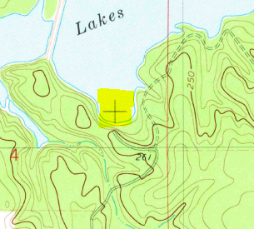

1. What these green dots in S18, T20N, R9W represent?

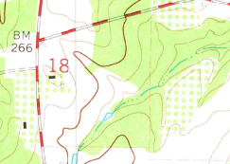

A orchards

B vineyards

C shrublands

D woodlands

E none of these

1. Why is this intersection between S13, S14, S23, S24, T20N, R9W like this?

A it’s a witness corner

B it’s a found section corner

C it’s a meandoring corner

D it’s a closing corner

E none of these

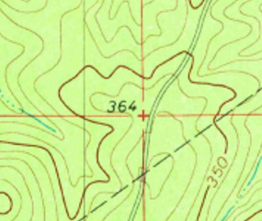

1. Describe this shaded parcel (use your printed map to find township and range):

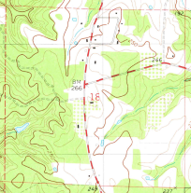

A SW1/4, S18, T20N, R9W

B SE1/4, S18, T20N, R10W

C SW1/4 of SE1/4, S18, T20N, R9W

D SE1/4 of SW1/4, S18, T20N, R10W

E none of these

1. A 1:24,000 scale makes 1” equal 24,000”. A mile is 5,280’ or 63,360”. Approximately, how many miles are in 11” on this map?

A 1

B 2

C 3

D 4

E 5

1. Sausman creek feeds into Bayou Dorcheat from the west and enters the bayou at NW1/4 of NW1/4, S18, T19N, R9W. What type of waterway is Sausman Creek?

A Perennial stream

B Intermittent river

C Disappearing stream

D Perennial river

E None of these

1. What would you expect to find in W1/2, S25, T20N, R10W?

A upland timber

B grassy marsh

C wooded marsh

D prairie

E None of these

1. How many combined acres are shaded in these parcels of land?

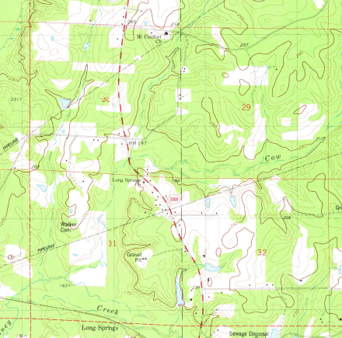

A 320

B 640

C 800

D 960

E 1280

1. How many square feet are in an acre?

A 640 f2

B 5280 f2

C 12,454 f2

D 43,560 f2

E none of these

1. Highlighted at this Neatline is longitude, what does it measure?

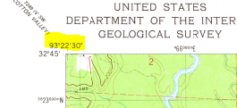

A North/South distance from the equator

B East/West distance from the Prime Meridian

C North/South distance from the poles

D East/West distance from the equator

E None of these

1. What is the benchmark’s elevation at Dorcheat where the unimproved road approaches the railroad track E1/2 of SW1/4, S36, T20N, R10W

A 160

B 170

C 180

D 190

E 200

1. What township and range does the Minden city limits reside in?

A T20N, R10W

B T20N, R9W

C T19N, R9W

D T19N, R10W

E NONE OF THESE

1. At the graticule intersection of 320 40’ 0” latitude and 930 17’ 30” longitude what do you find?

A woodland

B lake water

C pipeline crossing

D national forest

E none of these

1. What is crossing in the picture below (can be found in N1/2 of SE1/4, S35, T20N, R10W)

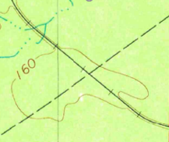

A railroad & pipelilne

B trail & railroad

C power line & railroad

D trail & unimproved road

E none of these

1. Which illustration properly depicts the directions these streams flow? (can be found in S9, T20N, R9W)

A 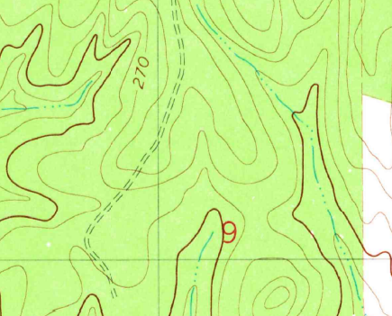

B 

C 

D 

1. What is the contour interval of this map?

A 10’ B 10” C 20’ D 20” E 100’

1. What is the lowest elevation in S2, T19N, R9W?

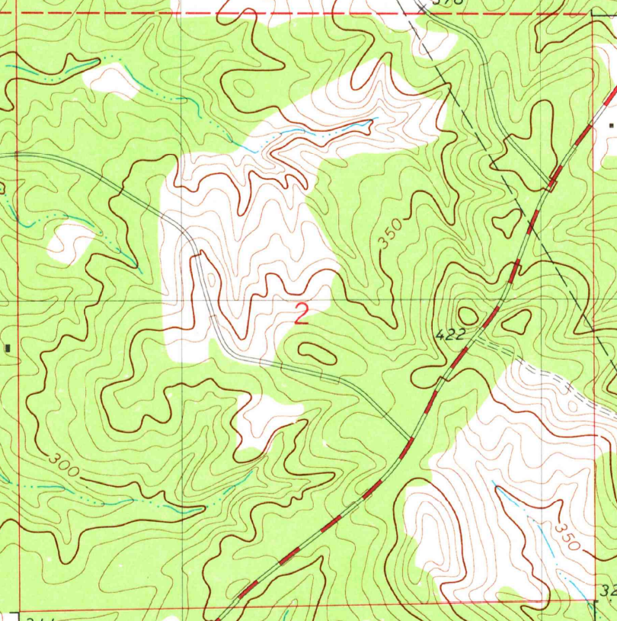

A 210 B 220 C 230 D 240 E 250

1. Which line symbol constitutes the section lines that act as a border for the Kisatchie National Forest in this map?

A 

B 

C 

D 

E 

1. What does the landscape look like in NW ¼, S17, T19N, R9W?

A sloping, woodland with creek/ponds

B sloping, fenced pastureland with creek/ponds

C flat, swampland with bayous

D flat, planted in row crops

E steep, woodlands with creek/ponds

1. How far would it be if you walked the railroad tracks from Dorcheat in S1/2, S36, T20N, R10W to Long Springs in N1/2 of N1/2, S6, T19N, R9W?

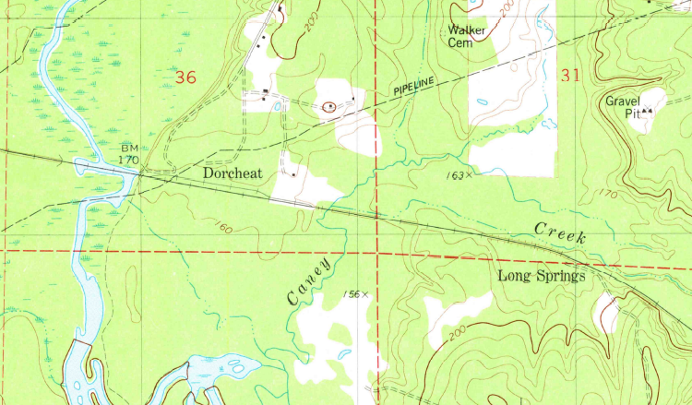

A ½ mile

B 1 mile

C 2 miles

D 2.5 miles

E 3 miles

1C

2A

3B

4E

5D

6A

7C

8C

9D

10B

11B

12C

13B

14A

15D

16A

17E

18B

19B

20B