**2022 Area I Forestry Map Reading Test (Practicum 1)**

DO NOT WRITE ON THIS PAPER! MARK ANSWERS UNDER PRACTICUM 1 ON SCANTRON.

**1. What is the elevation of the tank located in S23, T17N, R5E?**

A) 830

B) 840

C) 845

D) 850

E) 860

**2. What type of roadway surface does the symbol below represent?**



A) Primary highway, hard surface

B) Secondary highway, hard surface

C) Light duty road, hard surface

D) Light duty road, improved surface

E) Unimproved road surface

**3. Approximately what percentage of S20, T17N, R5E is covered by the Geist Reservoir?**

A) 5%

B) 10%

C) 20%

D) 40%

E) 80%

**4. The scale of this map is 1:24000, meaning an inch measured on the printed map represents 24,000 actual measured ground inches, or 2,000 feet. Approximately how many feet are between the intersection of Georgia Road and E 104th Street to the Tower located in S7, T17N, R6E?**

A) 1,500 feet

B) 1,750 feet

C) 2,000 feet

D) 2,500 feet

E) 3,000 feet

**5. What does the symbol below represent, as found in the SE ¼ of NE ¼, S26, T17N, R5E?**



A) School

B) Ranger Headquarters

C) Place of Worship

D) Fire Station

E) Hospital

**6. How many sections are in a typical township of land?**

A) 6

B) 36

C) 12

D) 640

E) 43,560

**7. The contour lines on the north end of Indian Lake in the SW ¼ of S29, T17N, R5E are very close together, signifying what topographical changes?**

A) Flat land near the lake

B) Rapidly changing elevation

C) Marsh area near lake

D) Protected riparian zone

E) All of the above

**8. What quadrangle is located directly east of the McCordsville quadrangle?**

A) Fishers

B) Riverwood

C) Cumberland

D) Lapel

E) Ingalls

**9. Describe the parcel of land shown in the illustration below:**

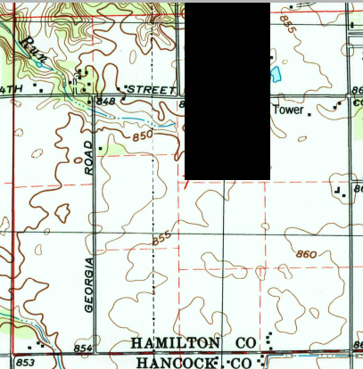

A) W ½ of NW ¼

B) W ½ of NE ¼

C) E ½ of NE ¼

D) E ½ of NW ¼

E) W ¼ of N ½

**10. The image below is used to determine declination and can be found at the bottom of your map. What does the abbreviation “GN” represent?**

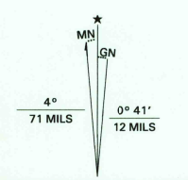

A) Grid north

B) Geographical north

C) Gravitational north

D) Greenwich navigation

E) None of the above

Key

1. D
2. B
3. C
4. E
5. A
6. B
7. B
8. E
9. B
10. A