Glider Plans

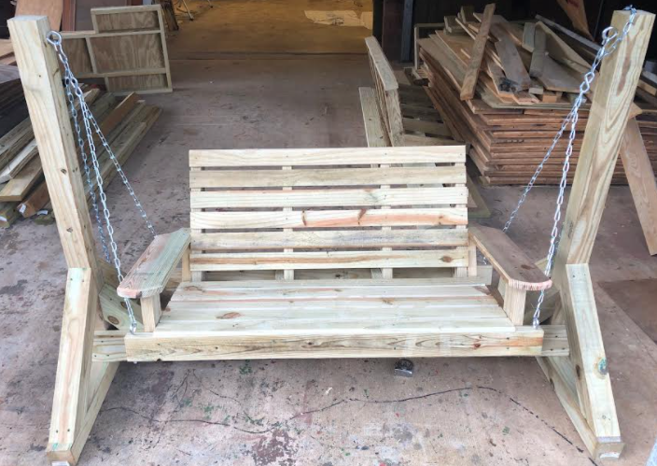

Materials list
5 - 1x6x8 Dog Eared Fence Boards (Ripped in half. These can be ripped at school and brought to the contest)
5 - 2x4x8 Treated
2 - 4x4x10 Treated
1 - 4x4x8 Treated
2 - 2x6x8 Treated
1 - 5/4 x 6” x 8’ Treated (decking board)
2- ½ x 6 eye bolts
4- 3/8 x 6 eyebolts with nuts
4 -10 inch lag screws with washers
1 - Swing Chain set
1 box (100 count) 4” deck screws
1 box (100 count) 2 ½” deck screws
1 box (100 count) 1 5/8” trim screws

Steps to build the Glider Frame

Step 1:
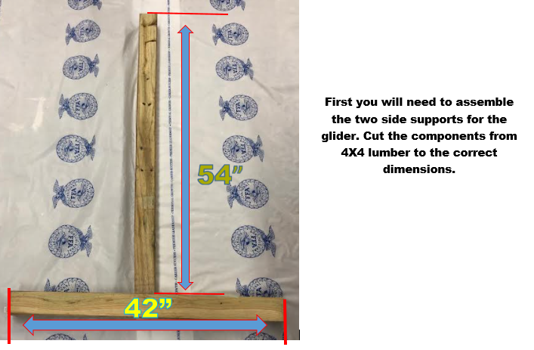

Step 2:
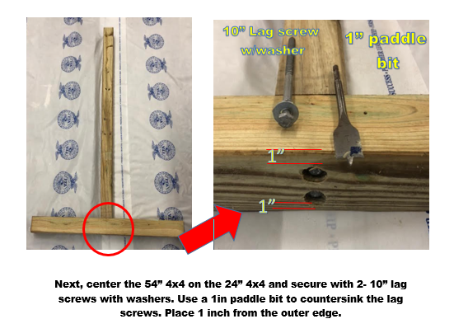
Step 3:
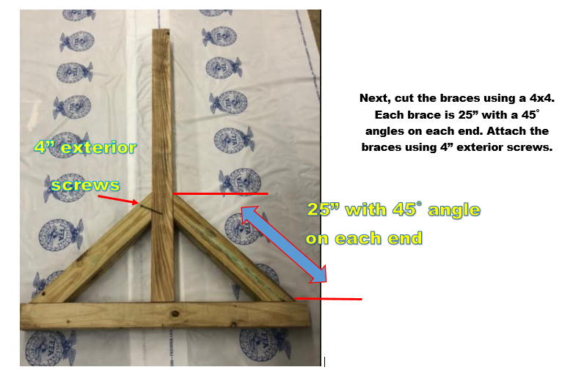
Step 4:
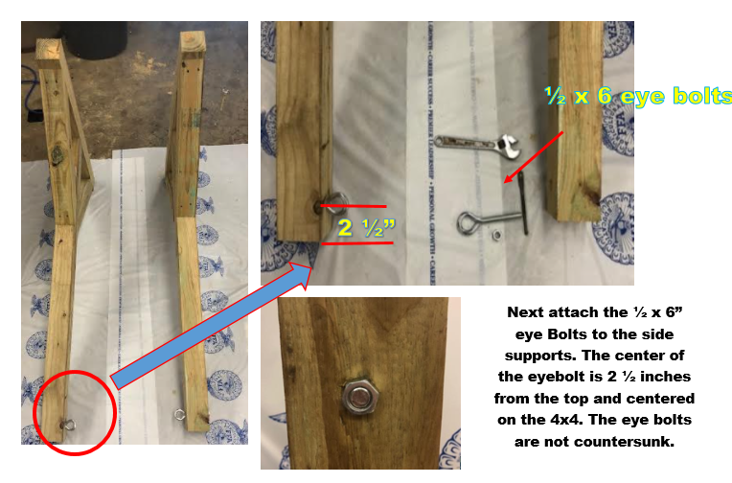
Step 5:
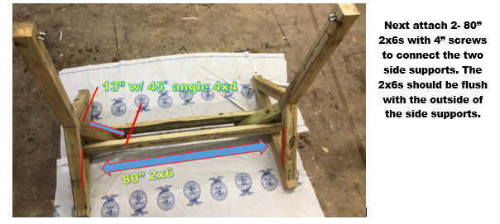

Step 6:
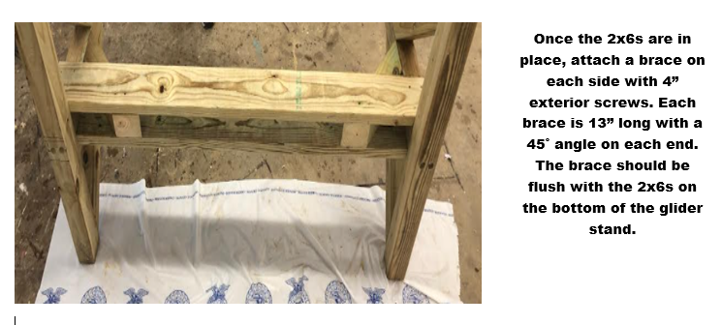
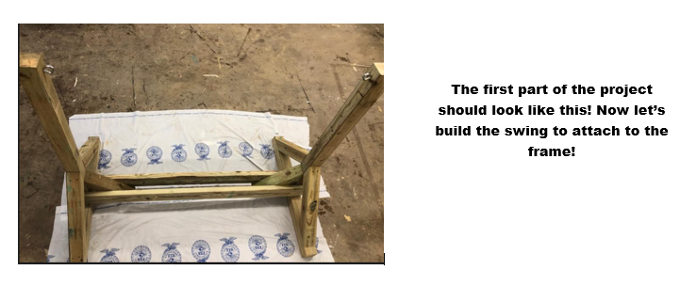

Steps to Build the Swing

Step 1:
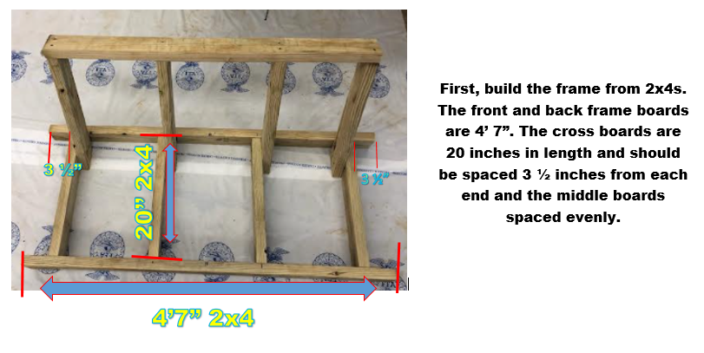

Step 2:
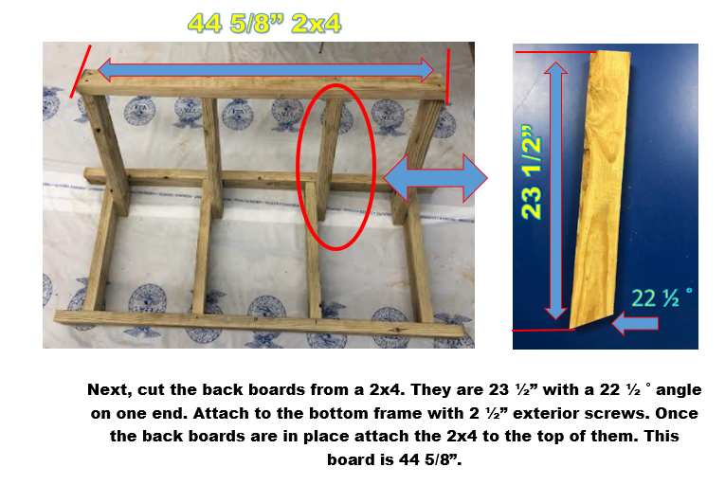
Step 3: 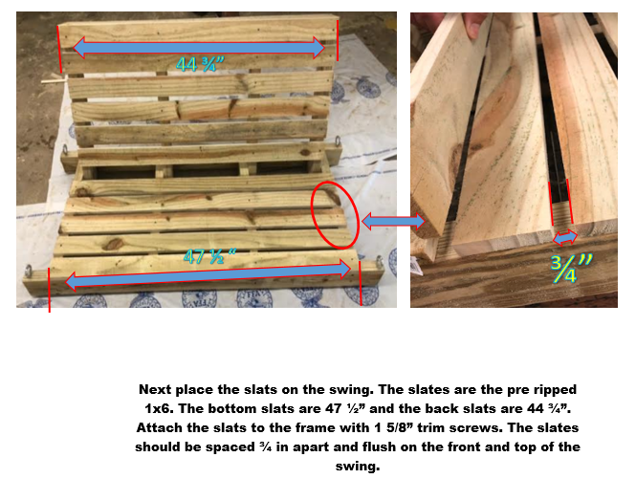
Step 4:
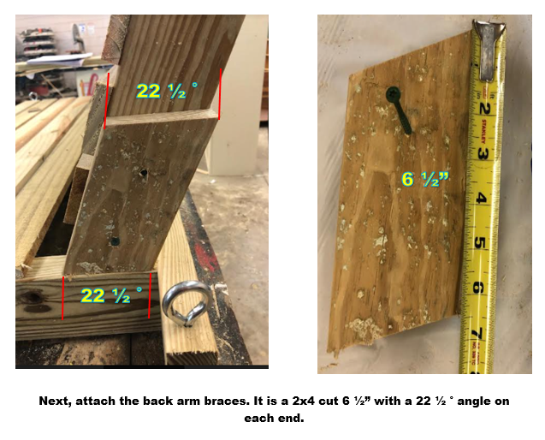
Step 5:
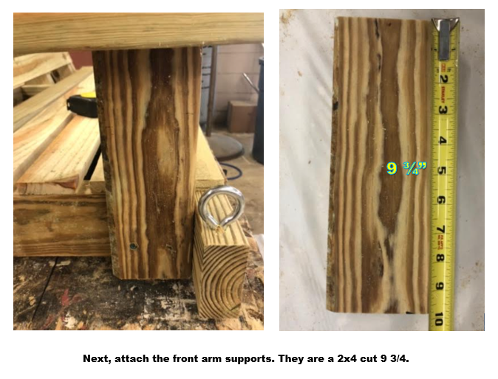
Step 6:
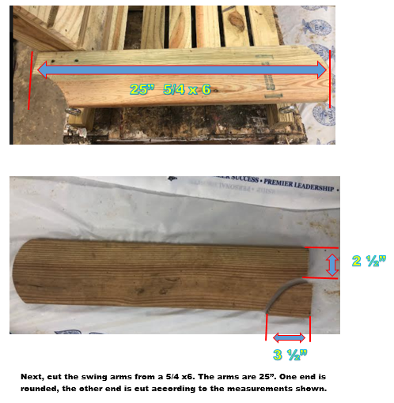
Step 7:
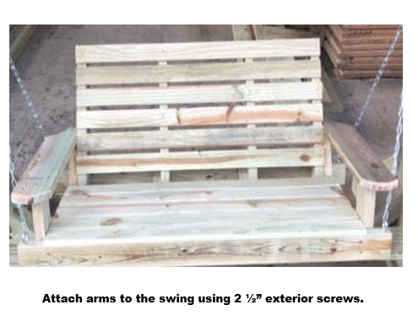

Step 8:
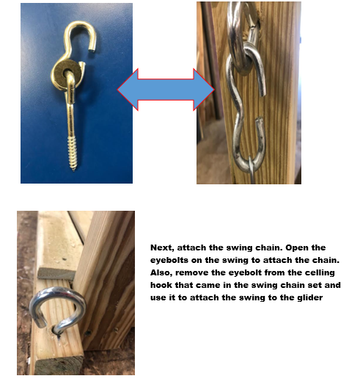
Step 9: 