**Practicum 1**

**1. What is the contour interval of this map?**

A. 5 feet

B. 10 feet

C. 20 feet

D. 100 feet

E. None of the above

**2. Most of the buildings in Hollister are in which section?**

A. 4

B. 5

C. 9

D. 10

E. None of the above

**3. Branson Hills church is on hwy 65, ____ miles north of the double looped exit in Branson.**

A. 1

B. 2

C. 3

D. 4

E. 5

**4. How many acres are in a half section?**

A. 320

B. 160

C. 80

D. 40

E. 20

**5. What creek runs through SW1/4, S27, T24N, R21W?**

A. Emory Creek

B. Bee Creek

C. Emory Creek

D. Bull Creek

E. Bear Creek

**6. What is the highest elevation in S1, T22N, R21W?**

A. 1100’

B. 1110’

C. 1120’

D. 1200’

E. 1300’

**7. How many sections are in a township?**

A. 1

B. 6

C. 12

D. 24

E. 36

**8. Which legal description best describes Silver Creek Lake to the nearest ¼ section?**

A. SW1/4, S12, T23N, R21W

B. NW1/4, S12, T23N, R12W

C. NW1/4, S12, T23N, R21W

D. NE1/4, S12, T23N, R21W

E. NE1/4, S12, T22N, R21W

**9. The top horizontal line of this map is at 36O 45’ north of the equator. What geographical coordinate is that horizontal line measuring?**

A. Longitude

B. Latitude

C. Elevation

D. Geodetic datum

E. None of the above

**10. What state is represented on this map?**

A. Louisiana

B. Arkansas

C. Missouri

D. Virginia

E. None of the above

**Practicum 2**

**1. Which of these should you always have on you at a felling site?**

A. Helmet with earmuffs and safety glasses

B. Communication device

C. Work gloves

D. Protective trousers/chainsaw chaps

E. All of these

**2. What two factors should determine the size/power of the chainsaw you use?**

A. Your age and number of acres to cut

B. Your weight and the name brand of the saw

C. Your experience and the type/size of tree

D. Your experience and the weather

E. Your height and strength

**3. A pulling chain means you are sawing with the ____.**

A. bottom of the bar

B. top of the bar

C. tree already on the ground

D. main trunk leaning

E. saw at half throttle

**4. The directional notch should not be cut too deep. What is the depth range it should be in % of DBH?**

A. 5-10% of DBH

B. 15-20% of DBH

C. 25-30% of DBH

D. 35-40% of DBH

E. 45-50% of DBH

**5. For safe movement when limbing, where should you always position the guide bar when moving?**

A. On top of the trunk

B. On the ground

C. On your side of the trunk

D. On the other side of the trunk

E. At your side

**6. What is this?**

A. clutch B. brake C. flywheel D. bar E. muffler

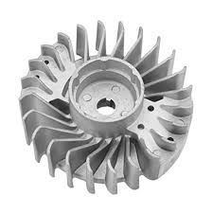

**7. If hand filing a chain on the saw at home you should make sure the chain brake is engaged and the bar is**

A. clamped in a vise

B. not in a vise

C. laying flat on a table

D. very loosely bolted on the saw body

E. none of the above

**8. What is number 3 pointing to?**

A. top plate B. side plate C. gullet D. depth gauge

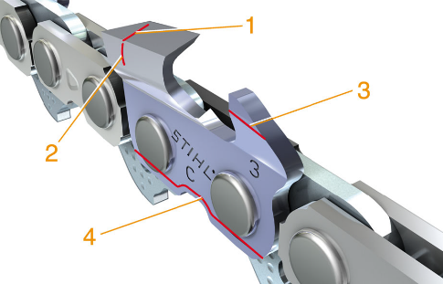

**9. What is the most important part in ensuring a safe clean felling?**

A. directional notch

B. felling cut

C. bore cut

D. hinge

E. none of the above

**10. The safest way to crank a chainsaw is**

A. with the chain brake disengaged

B. with the saw on the ground

C. while standing up with the handle in the left hand and cranking with the right

D. with the saw on the tailgate of a truck

E. while holding down on the throttle trigger

Practicum 1 KEY

Key

1 C

2 A

3 C

4 A

5 E

6 C

7 E

8 C

9 B

10 C

Practicum 2 key

1 E

2 C

3 A

4 B

5 D

6 C

7 A

8 D

9 D

10 B