**2022 Area IV Forestry Map Reading Test (Practicum 1)**

DO NOT WRITE ON THIS PAPER! MARK ANSWERS UNDER PRACTICUM 1 ON SCANTRON.

**1. The image below is used to determine declination and can be found at the bottom of your map. What does the abbreviation “MN” represent?**

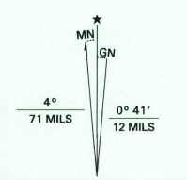

A) Metropolitan north

B) Magnetic north

C) Mercator north

D) Mediterranean navigation

E) None of the above

**2. What classification of roadway does the symbol below represent?**



A) Primary highway, hard surface

B) Secondary highway, hard surface

C) Light duty road, hard surface

D) Light duty road, improved surface

E) Unimproved road surface

**3. Approximately what percentage of S20, T17N, R5E is covered by land?**

A) 50%

B) 60%

C) 65%

D) 80%

E) 95%

**4. The contour lines near Fall Creek in the NW ¼ of S29, T17N, R5E are very close together, signifying what topographical changes?**

A) Flat land near the creek

B) Rapidly changing elevation

C) Marsh area near creek

D) Protected riparian zone

E) All of the above

**5. What does the symbol below represent, as found in the NE ¼ of NE ¼, S26, T18N, R5E?**



A) School

B) Ranger Headquarters

C) Place of Worship

D) Fire Station

E) Hospital

**6. What quadrangle is located directly north of the McCordsville quadrangle?**

A) Fishers

B) Riverwood

C) Cumberland

D) Lapel

E) Ingalls

**7. What is the elevation of the tower located in S7, T17N, R6E?**

A) 830

B) 840

C) 845

D) 850

E) 855

**8. The scale of this map is 1:24000, meaning an inch measured on the printed map represents 24,000 actual measured ground inches, or 2,000 feet. Approximately how many feet are between Cumberland Road and Mollenkopf Road in S8, T17N, R5E?**

A) 2,500 feet

B) 2,750 feet

C) 3,000 feet

D) 4,000 feet

E) 7,000 feet

**9. How many sections are in a typical township of land?**

A) 36

B) 6

C) 12

D) 640

E) 43,560

**10. Describe the parcel of land shown in the illustration below:**

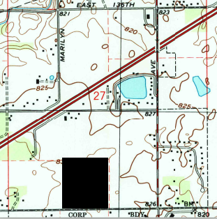

A) SE ¼ of NW ¼

B) SW ½ of NE ¼

C) SE ¼ of SW ¼

D) SE ½ of SW ¼

E) SW ¼ of SE ¼

Key

1. B
2. A
3. D
4. B
5. C
6. B
7. E
8. D
9. A
10. C