Practicum 2

1. A properly tensioned chain should:
2. Should have slack (hang) on the underside of the guide bar
3. Should not have slack on the underside of the guide bar
4. Cannot be pulled around the guide bar easily by hand with the chain brake off
5. Can be pulled around the guide bar easily by hand with the chain brake off
6. Both B and D
7. Identify the chain that needs to be discarded.

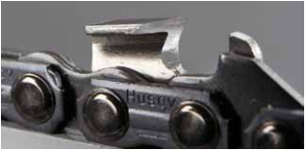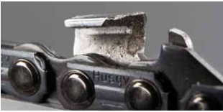

**D**

**C**

**B**

**A**

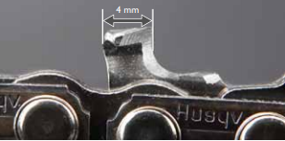 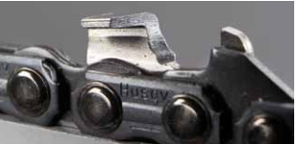

1. Identify the hinge

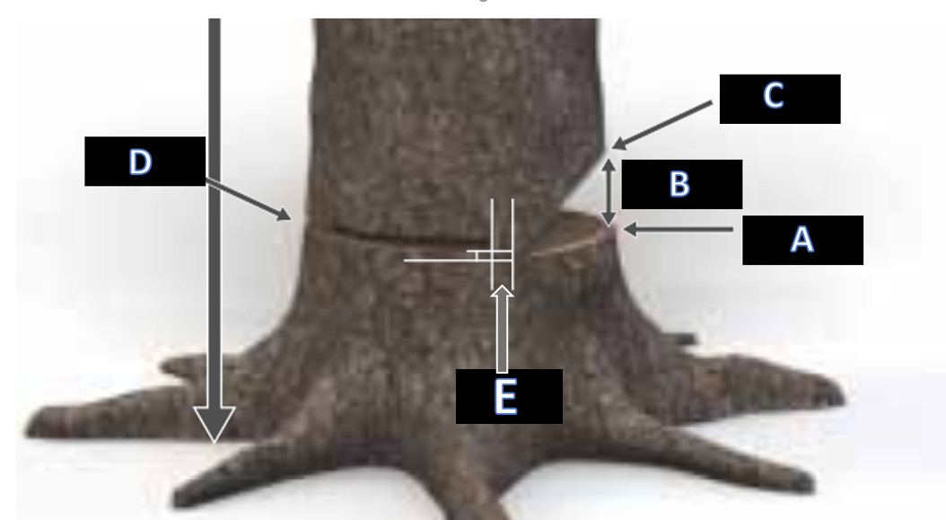

1. Identify the cutting tooth tip

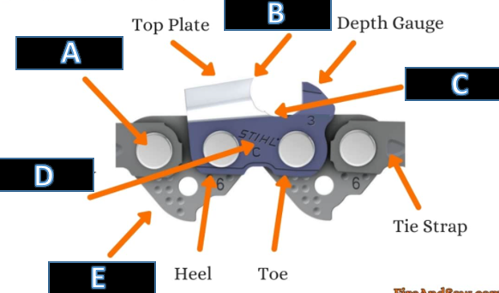

1. What is this area on the bar called?

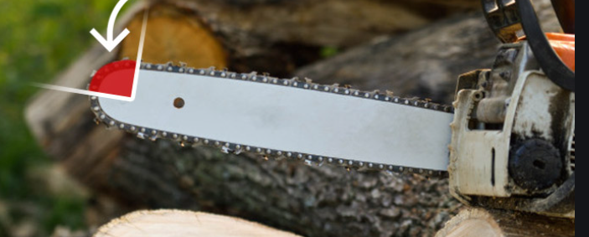

1. Pulling chain
2. Pushing Chain
3. Kickback zone
4. Sprocket
5. Boring zone
6. When limbing a tree’s top face (see picture below) you should always

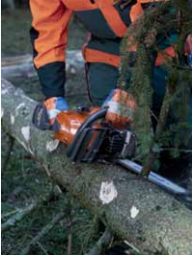

1. Saw with a pulling chain
2. Saw with a pushing chain
3. Place your right leg against the saws body
4. Both B and C
5. Identify the air filter covering

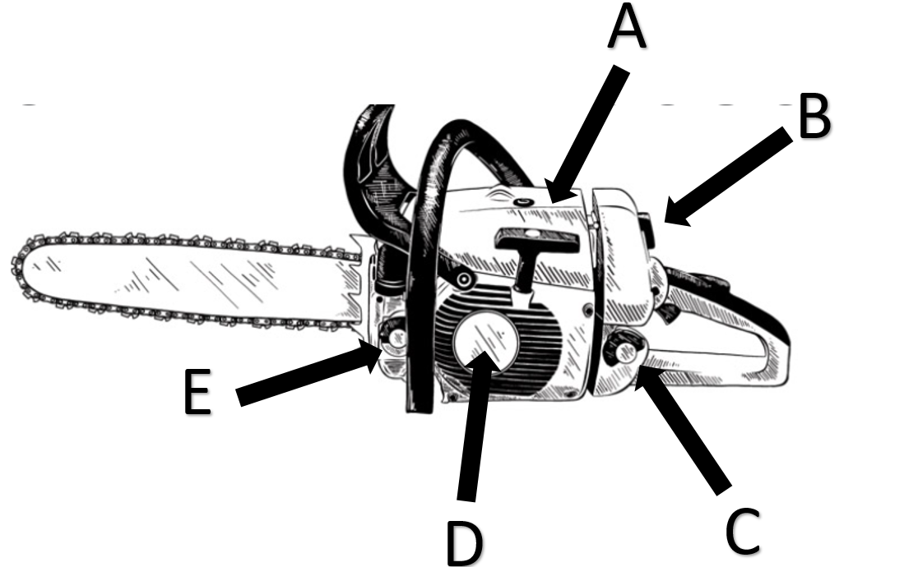

1. Identify the tension side of this log

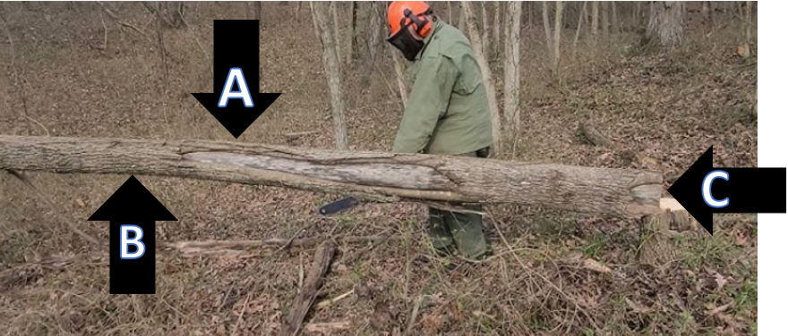

1. Name 1 PPE item from this answer choices missing from this picture.

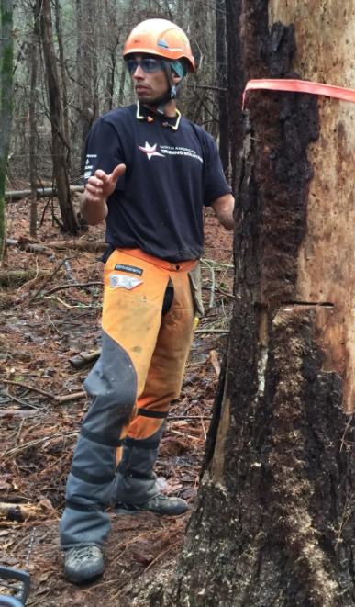

1. Hand protection
2. Ear protection
3. Eye protection
4. Head protection
5. What is this type of cut called?

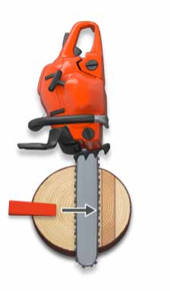

1. Felling cut
2. Bore cut
3. Hinge cut
4. Directional notch cut
5. None of these

1 E

2C

3E

4B

5C

6D

7B

8B

9A

10A