PRACTICUM 2

1. IDENTIFY THE CLUTCH DRUM BEARING

E

A

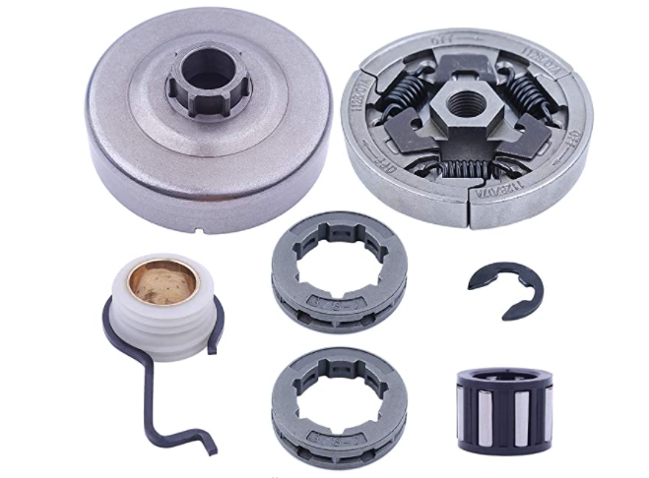

D

C

B

1. Identify the carburetor

C

D

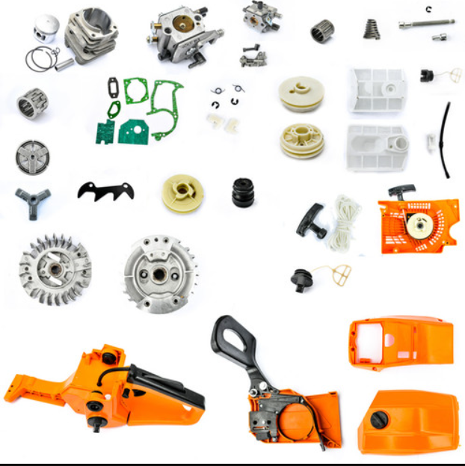

A

B

E

1. What is the correct cutting sequence for this situation (compression is on top). You will cut close to the stump so the log is not elevated over your head.

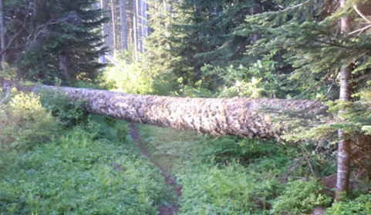

1. Cut 1/3 from the top until it feels like the tree may pinch the bar then finish from the bottom. Stagger the finishing cut by 1/2”- 1” to the right of the first cut.
2. Cut 1/3 from the top until it feels like the tree may pinch the bar, then finish from the bottom. Make the cuts meet.
3. Cut 1/3 from the bottom and finish from the top staggering the cuts by 1”
4. Cut 1/3 from the bottom until it feels like the tree may pinch the bar and finish from the top. Make the cuts meet.
5. Cut all the way through from bottom to the top.
6. What does this part do?

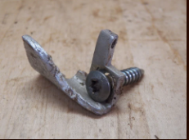

1. Catches the chain if it breaks or derails
2. Sharpens the chain as it goes by
3. Lubricates the guide bar with chain oil
4. Stops the chain when the brake is engaged
5. None of the above
6. What do these fins do?

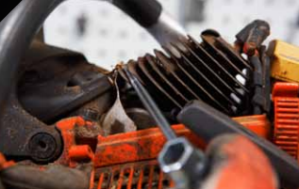

1. Lubricate the piston
2. Keep the engine from being too loud
3. Keep emissions safe
4. Cool the engine
5. None of the above
6. This tree is 20” in diameter. According to the Husqvarna manual recommendations, how deep should this notch cut go back into the tree?

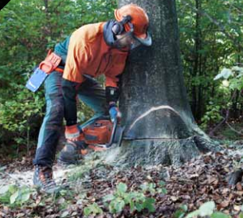

1. 3”-4”
2. 7”- 8”
3. 9” - 10”
4. 13” - 14”
5. 15” - 16”
6. Why would you need to cut a tree down like this?

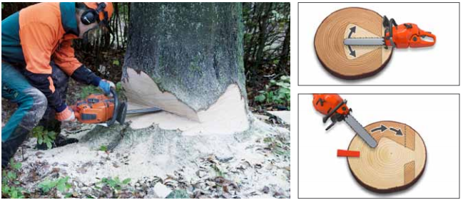

1. The saw is not powerful
2. The tree diameter is a little larger than the guide bar length
3. The tree diameter is twice the size of the guide bar length
4. Tree diameter is smaller than the guide bar length
5. What width should the hinge wood be on this tree?

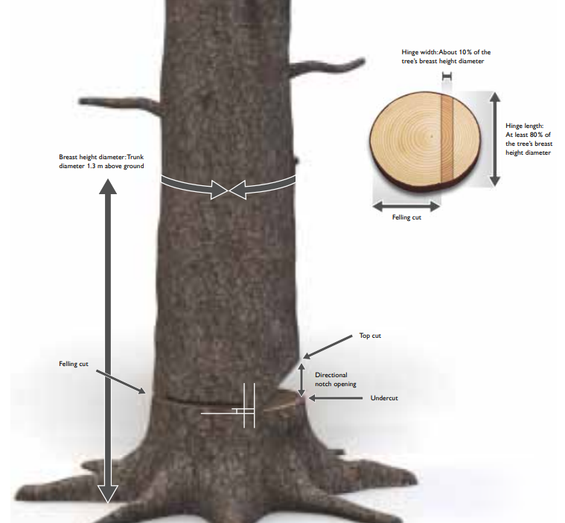

A 1”

B 2”

C 3”

D 4”

E 24”

**DBH 30”**

1. When limbing thick heavy branches, what is the basic rule?
2. Cut the branch flush with the trunk
3. Cut the branch off the trunk leaving 3”
4. Stand up on the tree and limb
5. Work from the outside of the bigger limb and in towards the trunk
6. Work from the inside of the bigger limb and out towards the end
7. Why would you do this?

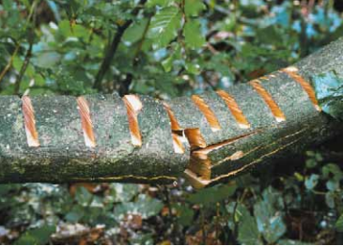

1. You couldn’t tell where the tension/compression was
2. You just sharpened your saw
3. Your tired and don’t want to work anymore
4. Limb tension needed to be released
5. None of the above
6. Identify the chisel of the saw tooth

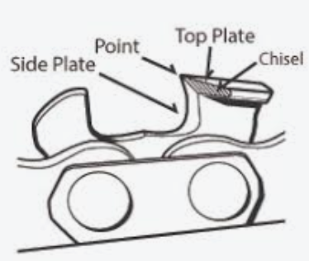

**D**

**C**

**B**

**A**

1. Which is the safest and most powerful way to fell a tree?
2. Using felling wedges
3. Using foot breaking bars
4. Using Impact bars
5. Using breaking bars
6. Using a rope and a winch
7. What tree felling method is this?

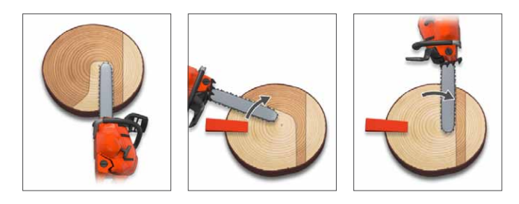

1. Cutting with bore
2. Turn around method
3. Safe corner method
4. Saved edge method
5. Felling cut straight from behind
6. What is your path of retreat?
7. Straight line directly behind the felling cut
8. 45 degree angled line in front of the directional notch
9. 45 degree angled line on either side behind the felling cut
10. Straight 90 degree line right or left of the felling cut
11. Straight line in front of the directional notch
12. What does “A” do?
13. Locks the throttle in high speed
14. Kills the engines
15. Prevents the engine from flooding
16. Prevents accidental throttle revving
17. None of the above

A

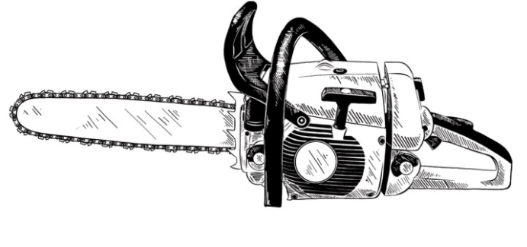

1. Which area would pinch your saw if you tried to cut it all the way through?

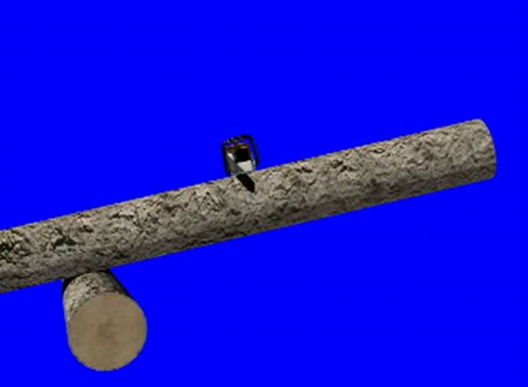

A

B

1. What could happen if you completely filed down the rakers?
2. The teeth would cut too deeply into the wood
3. The chances of kickback would greatly increase
4. The load on the engine of the saw could result in high vibrations
5. Chainsaw is exposed to unnecessary stress
6. All of the above
7. If sharpening your saw in your shop, what is the first thing you should do?

A. Lock the guide bar in a bench vice

B. File down the depth gauges

C. Begin filing at 25-25 degrees

D. Deactivate the chain brake

E. None of the above

1. If you do NOT have the skills, capability or experience to cut this leaning tree, what is the smartest/safest thing you should do in this scenario?

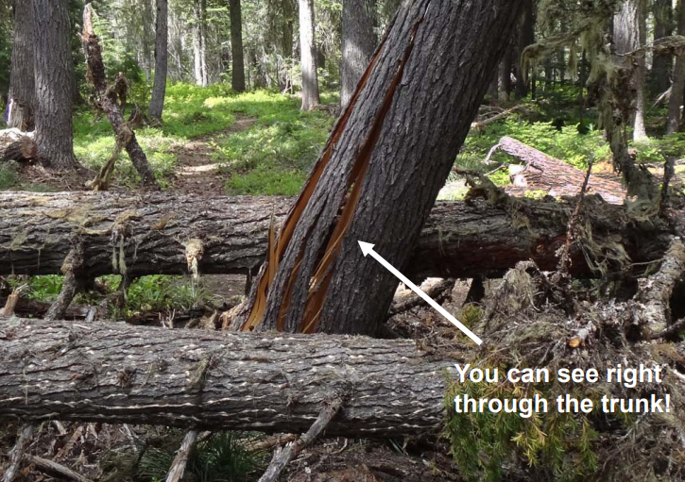

A Rope off the area with safety flagging and leave

B Go borrow a tractor and try to cut it

C Cut the trees on the ground and leave the leaner alone

D Just go slow and hope everything turns out OK

1. An inverse directional notch like this is called a what?

A California

B Key notch

C Humboldt

D Open face

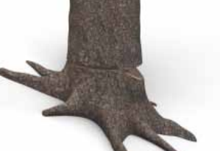

1C

2D

3A

4A

5D

6A

7C

8C

9D

10D

11D

12E

13B

14C

15D

16B

17E

18A

19A

20C