**2022 State Forestry CDE – Map Reading Exam (Practicum 1)**

DO NOT WRITE ON EXAM! MARK ALL ANSWERS ON SCANTRON UNDER PRACTICUM 1.

**1. How many square feet are in an acre of land?**

A) 640

B) 43,560

C) 36,678

D) 24,000

E) None of the above

**2. To convert distance from feet to meters on this map, multiply by __________.**

A) 3.048

B) 3

C) .3048

D) 2.95

E) None of the above

**3. What type of route is signified by the symbol surrounding this highway number?**

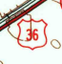

A) Unimproved route

B) US route

C) State route

D) Interstate route

E) None of the above

**4. Approximately how many acres are shaded in this section?**

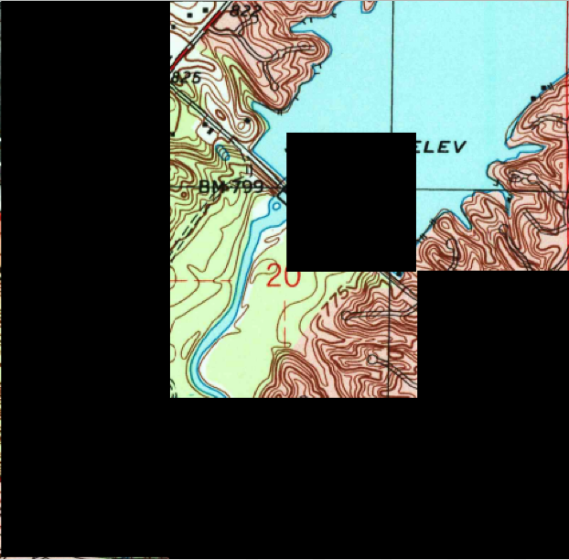

A) 220

B) 320

C) 440

D) 360

E) 400

**5. What type of waterway is Bee Camp Creek classified as within S18, T17N, R6E?**

A) Perennial stream

B) Intermittent stream

C) Perennial river

D) Disappearing stream

E) None of the above

**6. Describe the parcel of land shaded in the illustration below.**

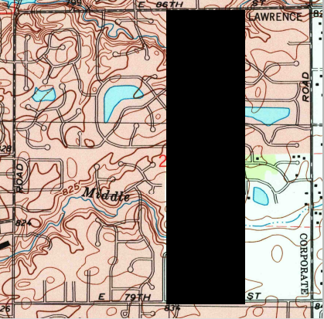

A) W ½ of E ½

B) E ½ of W ½

C) E ¼ of W ½

D) W ¼ of E ½

E) None of the above

**7. How many acres are in a typical section of land?**

A) 180

B) 36

C) 320

D) 480

E) 640

**8. At what contour line elevation is Bethlehem Church located in S26, T18N, R5E?**

A) 844

B) 845

C) 840

D) 835

E) 850

**9. What does the area where four red lines meet shown in the illustration represent?**

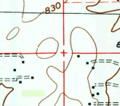

A) Witness corner

B) Found section corner

C) Meander corner

D) Benchmark coincident

E) None of the above

**10. The topography for this map was compiled in 1962. The planimetry was derived from imagery taken in what year?**

A) 1998

B) 1983

C) 1962

D) 1927

E) None of the above

**11. The scale for this map is 1:24000, meaning that an inch on the printed map is equivalent to ____________ feet of actual ground distance.**

A) 24,000

B) 12,000

C) 6,000

D) 2,000

E) None of the above

**12. Which of the following can be found within S26, T17N, R5E?**

A) School

B) Cemetery

C) US Route

D) Place of worship

E) All of these

**13. What county is the spillway on Geist Reservoir located?**

A) McCordsville

B) Hamilton

C) Marion

D) Hancock

E) None of the above

**14. This symbol found in S20, T17N, R5E signifies what type of area?**



A) Wildlife reserve

B) Marsh or swamp

C) Submerged wooded marsh or swamp

D) Mangrove

E) Protected wetlands

**15. What type of road surface is State Route 238 within S23, T18N, R5E?**

A) Primary highway, hard surface

B) Secondary highway, hard surface

C) Light duty road, hard surface

D) Light duty road, improved surface

E) Unimproved road

**16. According to this map, what land feature would you most likely not find in S14, T17N, R5E?**

A) Changes in elevation near waterways

B) Water

C) Woodlands

D) Open, flat ground

E) Gravel pit

**17. Thor Run is found within the SE quadrant of S1, T17N, R5E. As you move your finger on the map southeast of Geist Reservoir, the elevation _______________, meaning Thor Run flows ____________.**

A) Increases, northwest

B) Decreases, northwest

C) Increases, southeast

D) Decreases, southeast

E) None of the above

**18. What elevation is the school building located in S26, T17N, R5E?**

A) 845

B) 850

C) 855

D) 860

E) 865

**19. How many square miles are in a typical township?**

A) 1

B) 6

C) 18

D) 36

E None of the above

**20. Without going on-site to measure actual ground distance, what instrument would most accurately measure the distance of the Stanbury Ditch shown on this map in S25, T17N, R5E?**

A) Ruler

B) Planimeter

C) Stereoscope

D) Distance scale on map

E) Field lens

Key

1. B

2. C

3. B

4. D

5. B

6. A

7. E

8. C

9. B

10. A

11. D

12. E

13. C

14. B

15. B

16. E

17. A

18. C

19. D

20. B