**2022 Area III Forestry Map Reading Test (Practicum 1)**

DO NOT WRITE ON THIS PAPER! MARK ANSWERS UNDER PRACTICUM 1 ON SCANTRON.

**1. What does the symbol below represent, as found in the SE ¼ of NE ¼, S26, T17N, R5E?**



A) School

B) Ranger Headquarters

C) Place of Worship

D) Fire Station

E) Hospital

**2. The contour lines near Geist Reservoir in the E ½ of E ½ of S17, T17N, R5E are very close together, signifying what topographical changes?**

A) Marsh area near creek

B) Protected riparian zones

C) Flat land near the creek

D) Rapidly changing elevation

E) All of the above

**3. How many sections are in a typical township of land?**

A) 6

B) 36

C) 12

D) 640

E) 43,560

**4. The scale of this map is 1:24000, meaning an inch measured on the printed map represents 24,000 actual measured ground inches, or 2,000 feet. Approximately how many feet are between Lowery Cemetery and the intersection at East 141st Street and School Road in S21, T18N, R5E?**

A) 1,500 feet

B) 1,750 feet

C) 2,500 feet

D) 3,250 feet

E) 4,000 feet

**5. What is the elevation of the gas well located in S27, T17N, R5E?**

A) 835

B) 840

C) 820

D) 825

E) 830

**6. Describe the parcel of land shown in the illustration below:**

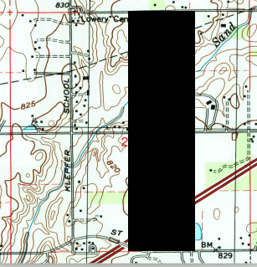

A) E ¼ of W ¼

B) W ½ of E ¼

C) W ½ of E ½

D) E ½ of W ½

E) W ¼ of E ½

**7. What quadrangle is located directly south of the McCordsville quadrangle?**

A) Fishers

B) Riverwood

C) Cumberland

D) Lapel

E) Ingalls

**8. The image below is used to determine declination and can be found at the bottom of your map. What does the star represent?**

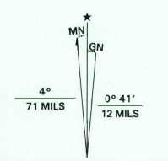

A) Magnetic north

B) True north

C) Mercatur north

D) Polar north

E) None of the above

**9. Approximately what percentage of S27, T18N, R5E is covered in water?**

A) 5%

B) 10%

C) 15%

D) 20%

E) 25%

**10. What classification of roadway does the symbol below represent?**



A) Primary highway, hard surface

B) Secondary highway, hard surface

C) Light duty road, hard surface

D) Light duty road, improved surface

E) Unimproved road surface

Key

1. A
2. D
3. B
4. C
5. E
6. C
7. C
8. B
9. A
10. C