Directions: Figure out the total number of boards and total cost to build 5 of these trash cans.
Work out your math on paper but write your final answer in the table at the bottom of the page.
Dimensions of cut boards for one trash can
- A – 18 – 2×4 – 1′ 6″
- B – 4 – 2×4 – 1′ 5 1/2″
- C – 4 – 2×4 – 1′ 8″
- D – 4 – 2×4 – 1′ 2 1/2″
- E – 4 – 2×4 – 3 1/2″
- F – 2 – 2×4 – 1′ 9″ (45-degree angle cuts)
- G – 2 – 2×4 – 1′ 9 1/2″ (45-degree angle cuts)

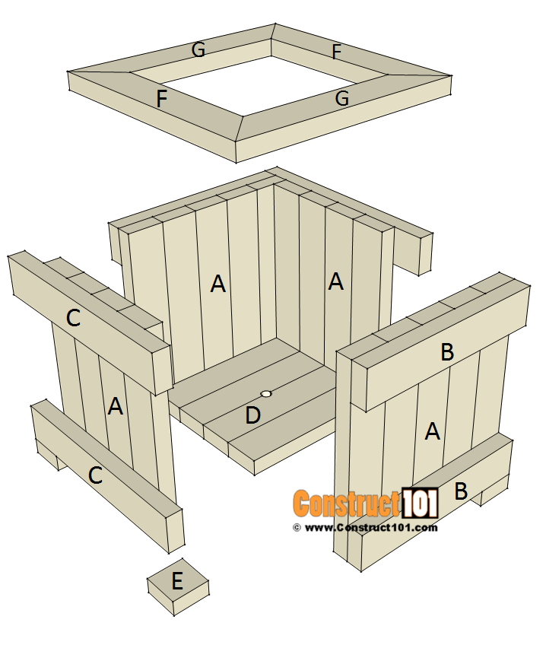

Materials | price
2”x4”x8’ treated | 3.97 per board
Sales tax | 8.00%

Number of 2”x4”x8’ boards needed to build 5 cans | Total cost of wood plus taxes to build 5 cans

Key
# of 2”x4”x8’ boards needed to build 5 cans | Total cost of wood plus taxes to build 5 cans
30 | $128.63

Grading # of boards Grading total cost
<39 = 0 points $208.63
2 points
37-38 = 2 points $188.63
4 points
35-36 = 4 points $168.63
6 points
33-34 = 6 points $148.63
8 points
31-32 = 8 points $138.63
10 points
30 = 10 points 10 points = $128.63
10 points
29-28 = 8 points $118.63
8 points
27-26 = 6 points $108.63
6 points
25-24 = 4 points $88.63
4 points
23-22 = 2 points $68.63
2 points
<21 = 0 $48.63

Multiplied by 5
Tax added back to cost of one can
8% tax applied to one can total cost
6 boards per can
Note: you can figure 30 boards times the cost per board (3.97) and apply tax (8% = $9.53) to net total (119.10) and still come out with the correct answer of $128.63

