**Practicum 1**

**1. What is the contour interval of this map?**

A. 5 feet

B. 10 feet

C. 15 feet

D. 20 feet

E. None of the above

**2. What town is in S12, T23N, R21W?**

A. Rockaway beach

B. Branson

C. Merriam Woods

D. Longbeach

E. Hollister

**3. How many sections are in a Township?**

A. 1

B. 6

C. 12

D. 24

E. None of the above

**4. How many acres are in a ¼ section?**

A. 640

B. 320

C. 160

D. 80

E. 40

**5. What elevation is the radio tower in NE1/4 of NW1/4, S2, T22N, R21W**

A. 800’

B. 900’

C. 1000’

D. 1100’

E. 1200’

**6. What U.S. Route runs North/South through Branson?**

A. I-165

B. I-65

C. U.S. 160

D. U.S. 65

E. U.S. 165

**7. South Emory Creek, North Emory Creek and Emory creek all flow into**

A. Bee Creek

B. Bull Creek

C. Roark Creek

D. Horseman creek

E. Silver Creek

**8. What part of Missouri is Branson?**

A. Southwestern

B. Northwestern

C. Northern

D. Eastern

E. Central

**9. Which direction does this stream flow?**

A. B. C. D.

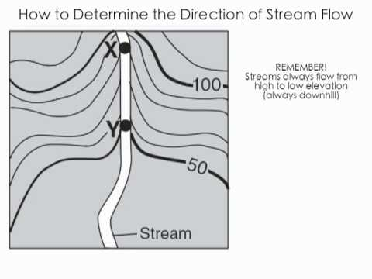

10. What body of water borders the city of Branson on the east and south?

A. Silver creek lake

B. White River

C. Lake Taneycomo

D. Roark Creek

E. None of the above

Key

1 D

2 A

3 E

4 C

5 D

6 D

7 B

8 A

9 C

10 C