State Forestry CDE Chainsaw exam

Please bubble in answers for Chainsaw exam under **“Practicum 2”**

**B**

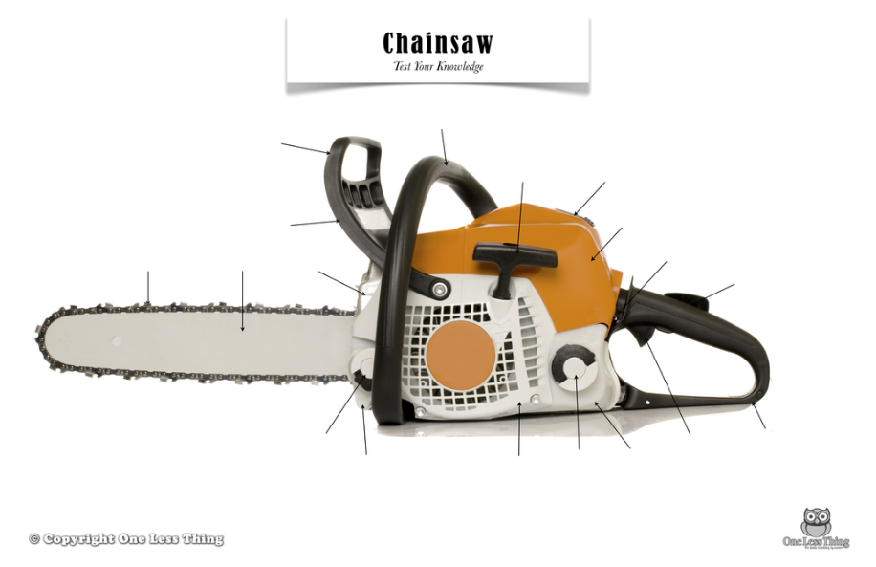

**A**

**C**

**A**

1. What is the part labeled A?
2. Starter rope
3. Chain guide
4. Oil cap
5. Front handle
6. Bar
7. What is the part labeled B?
8. Rear handle
9. Front Handle
10. Guide
11. Throttle
12. None of the above
13. What is the part labeled C?
14. Gas fill cap
15. Bar/chain Oil reservoir
16. Depth gauge
17. Bar/Chain Oil cap
18. Air filter cover
19. Before filing/sharpening a used chain the chainsaw bar should be:
20. Removed from the chainsaw
21. Locked in a vice or stump vice
22. Properly oiled
23. Sharpened first
24. Loosened from the clutch
25. What do we call the area labeled “B” in the stump picture?
26. Top cut
27. Wedge
28. Back cut
29. Notch
30. None of the above

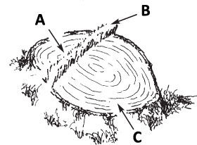

1. The length of the hinge should be 80% of the trees DBH, how wide should the hinge be?
2. 5%
3. 10%
4. 25%
5. 50%
6. None of the above
7. You are cutting a tree that is 80’ tall. During your felling plan, how far away should you make sure people are from the tree being cut down?
8. At least 40’
9. At least 80’
10. At least 120’
11. At least 160’
12. None of the above
13. What part of the bar below is the kickback zone?

B

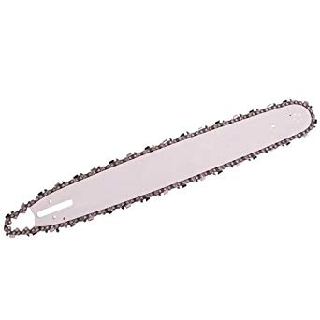

A

C

D

E

1. What type of notch is this below?
2. Conventional
3. Humboldt
4. Open face
5. Bore cut
6. None of the above

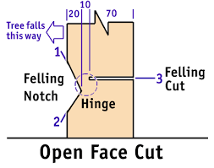

1. In the picture below, the chainsaw operator is performing a
2. Felling cut
3. Notch cutting
4. Bore cut
5. Top cut
6. Bottom cut

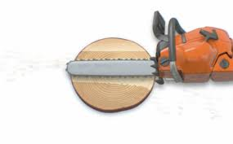

1. What is commonly referred to as the most important factor in terms of having a safe/clean felling?
2. Hinge
3. Directional notch
4. Trigger
5. Felling wedge
6. Undercut
7. When limbing, it is recommended by Husqvarna that you always stand on which side of the fallen tree?
8. Left
9. right
10. This log from left to right is about 2 feet above the ground. This person is crosscutting this large log. There is compressive stress on the topside of the log and tension on the bottom. Which set of steps provides the safest cutting of this log?

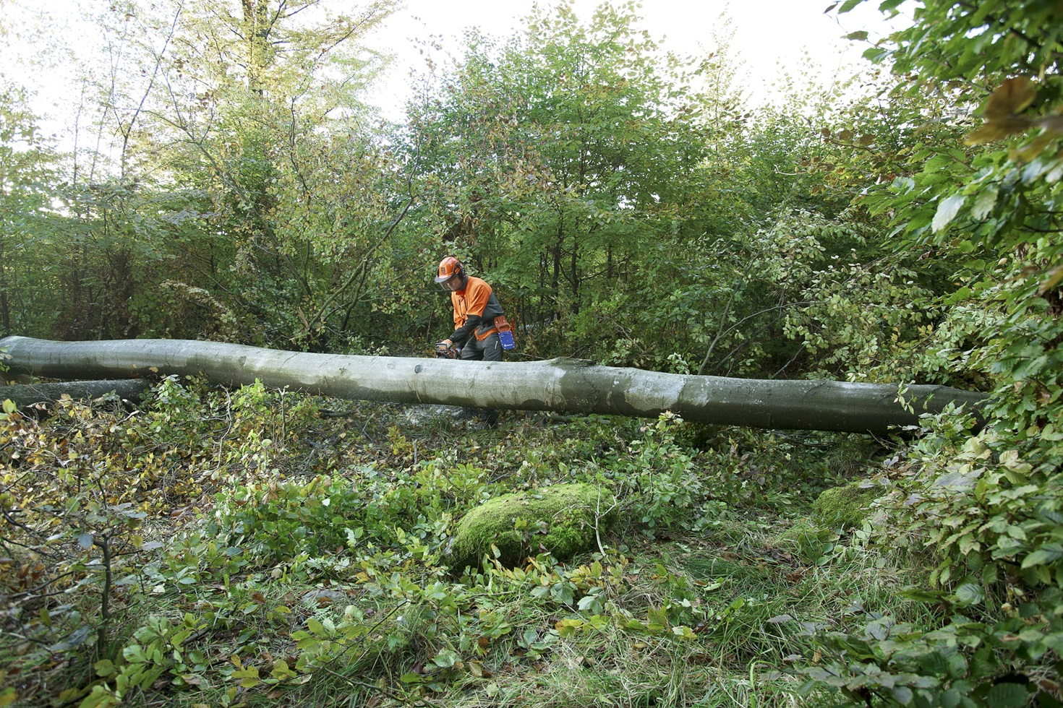

1. Cut 1/3 from the top, finish from the bottom
2. Cut 100% from bottom to top without stopping
3. Cut 1/3 of the log starting at the top then stop, insert felling wedge to the cut just made to prevent pinch, finish cut from the bottom.
4. Cut 1/3 from the bottom, engage chain brake, finish cutting from the top
5. Cut 1/3 of the log starting at the top then stop, engage chain brake, set the saw down, insert felling wedge to the cut just made to prevent pinch, disengage chain brake, finish cut from the bottom.
6. What is this chainsaw part?

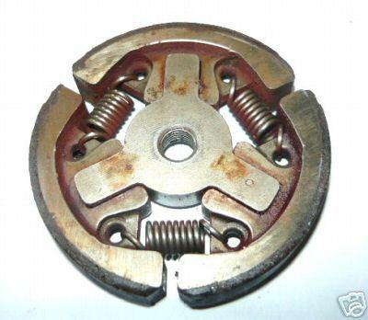

A. muffler

B. throttle cover

C. sprocket

D. clutch

E. spark plug

1. What are these called?

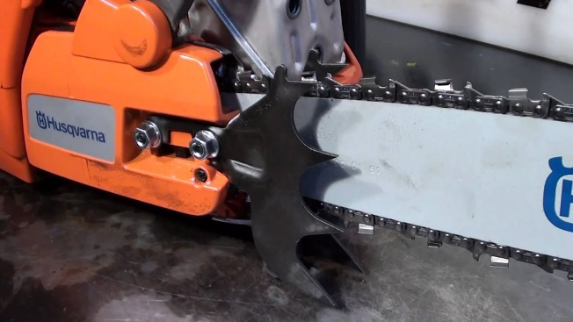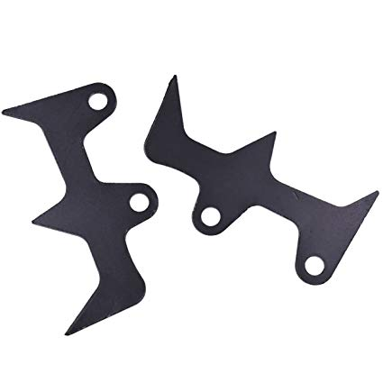

1. Bumper spikes
2. Chain brakes
3. Tensioners
4. Sprockets
5. None of the above
6. What is the part of the saw-chain called that the arrow is pointing to?

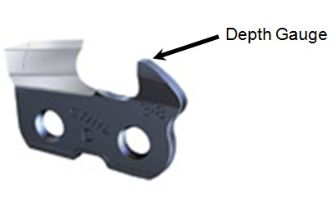

A Depth file or “guide”

B Depth Guide or “Braker”

C Depth Gauge or “Raker”

D Flat plate or “cleaner”

E Top plate or “chipper”

1. What type of file should you buy to sharpen a Husqvarna H42 chain?

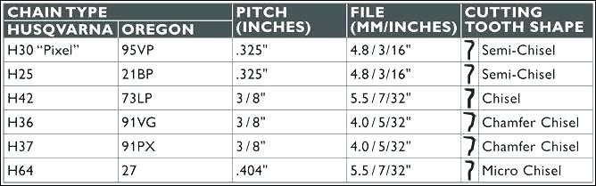

1. 3/8” file
2. Chisel file
3. 4.0mm (5/32”) file
4. 5.5mm (7/32”) file
5. 73LP File
6. Let’s assume this person’s pants are chainsaw proof; what else would make this person safer for a full day of tree cutting?

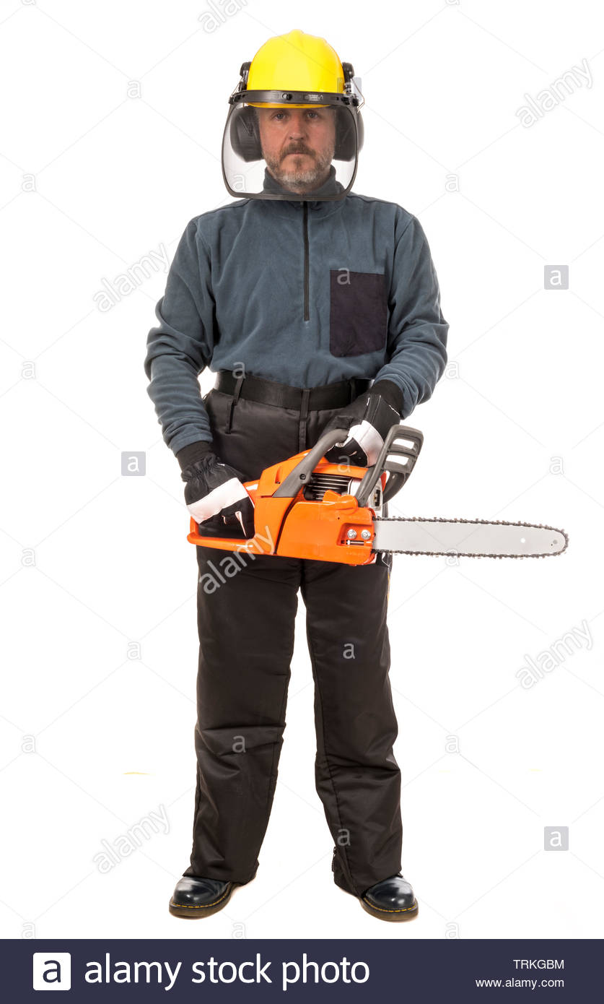

1. He should have a first aid kit nearby
2. He should have safety glasses
3. He should have high visibility clothing like orange/green
4. He should have a cell phone or radio to call out in case of emergency
5. All of the above
6. The size of a chainsaw depends on piston displacement and engine power. The size of chainsaw a person decides to purchase depends largely on which two factors.
7. Standardized test scores and operator experience
8. Operator experience and tree identification skill
9. Tree size you are cutting down and the type of wood the tree is
10. Tree size and operator experience
11. Tree size and season of the year
12. What is this diagram explaining?
13. This explains a proper felling plan
14. This explains a proper escape path
15. This explains the safe corner method
16. This explains how to roll a tree
17. None of the above

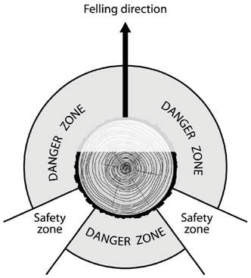

Key

1 E

2 B

3 D

4 B

5 E

6 B

7 D

8 B

9 C

10 C

11 A

12 A

13 E

14 D

15 A

16 C

17 D

18 E

19 D

20 B