Practicum 2 Chainsaw Exam

1. What is this part? A. handle

B. chain catcher

C. exhaust port

D. chain brake

E. sprocket

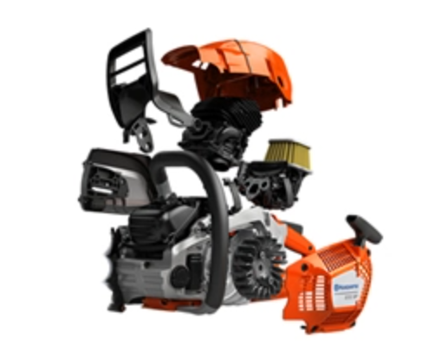

1. What is a general rule of thumb for when to sharpen a chain?
2. At the beginning of the day
3. At the end of the day
4. When you break for lunch
5. Every time you refuel
6. Whenever you have time
7. What is this type of cut called?

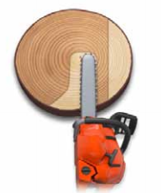

1. Bore
2. Notch
3. Hinge
4. Felling
5. None of these
6. Choose the one true statement about cutting all the way through this log from point “A” to point “B”?

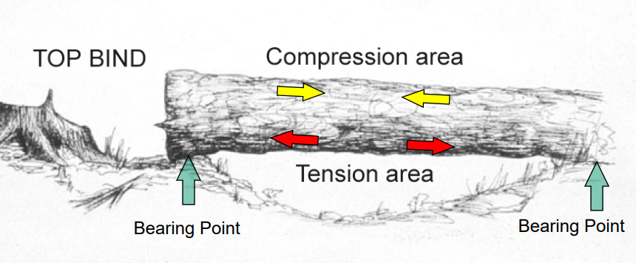

**Point A**

**Point B**

1. You should not cut all the way from point A to point B because point A is full of compression stress and will pinch the chainsaw if cutting all the way through the log from point A to point B
2. You should cut all the way through from point A to point B because Point A is full of compression stress and will NOT pinch the chainsaw if cutting all the way through the log from point A to point B
3. You should not cut all the way through from point A to point B because point A is full of tension stress and will pinch the chainsaw if cutting all the way through the log from point A to point B
4. You should cut all the way through from point A to point B because Point A is full of tension stress and will NOT pinch the chainsaw if cutting all the way through the log from point A to point B.
5. Identify the kickback zone.
6. 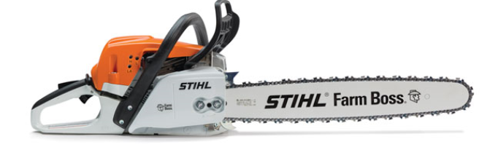
7. 
8. 
9. 
10. Identify the rivet.

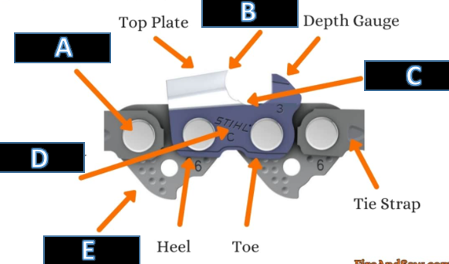

1. Identify the drive link



1. Identify the felling cut

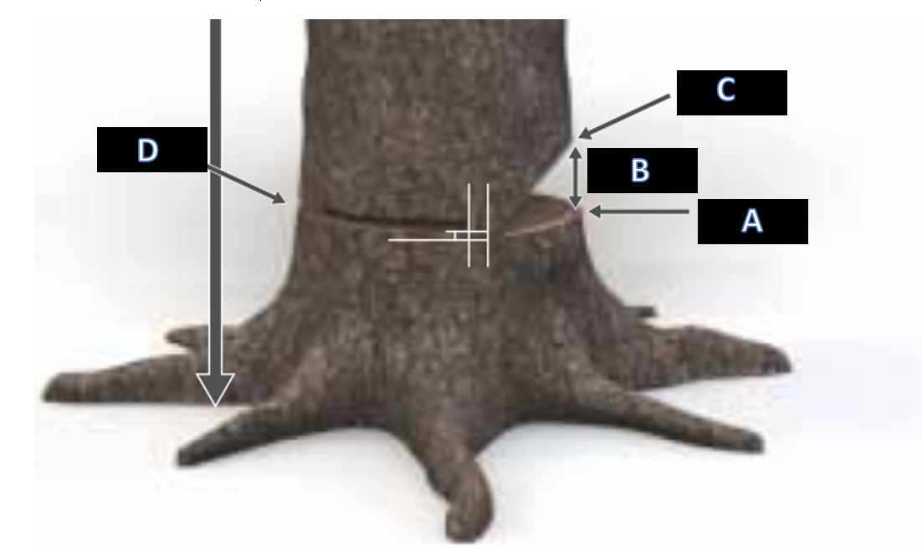

1. When limbing a fallen tree, which of the following is true.
2. You should start at the treetop end and limb from the right side towards the stump end
3. You should start at the treetop end and limb from the left side towards the stump end
4. You should start at the stump end and limb from the right side towards the top end
5. You should start at the stump end and limb from the left side towards the top end
6. What should you always carry in your pocket when working in the woods with a chainsaw?
7. Water
8. Food
9. Phone
10. Wallet
11. Keys

Key

1 D

2 D

3 A

4 A

5 A

6 A

7 E

8 D

9 D

10 C