**Area 4 Practicum 1**

1. Below, what do these highlighted number/symbols mean (can be found in the Neatline at the top right hand corner of this map?

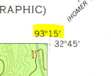

A longitude

B latitude

C Graticule

D Quadrangle

E None of these

1. According to USGS topographic map symbols, Bayou Dorcheat in W1/2, S13, T20N, R10W is a

A intermittent stream

B perennial stream

C intermittent river

D perennial river

E None of these

1. What is running parallel with the pipeline in SE1/4, S12, T19N, R10W

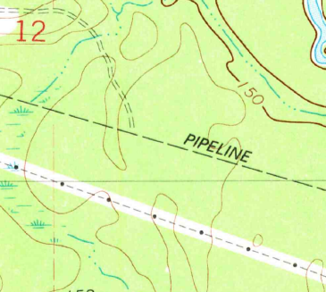

A railroad

B highway

C powerline

D bridge

E none of these

1. How many acres are shaded?

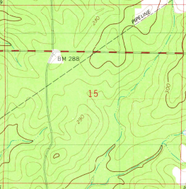

A 320

B 160

C 80

D 40

E None of these

1. What’s the highest elevation in S2, T19N, R9W

A 300

B 350

C 400

D 422

E 450

1. What two state highways can be found running the entire map from North-South?

A 3008 & 159

B 3008 & 534

C 159 & 534

D 7 & 3008

E 7 & 159

1. How many designated picnic areas does Caney Lakes have?

A 0

B 1

C 2

D 3

E 4

1. What will you find in SW1/4 of SW1/4, S34, T20N, R9W

A mostly trees

B mostly city

C mostly grass

D mostly water

E None of these

1. The way the crow flies, how far is it from Long Springs Church found N1/2 of NE1/4, S31, T20N, R9W to Mt Comfort Church found N1/2 of NE1/4, S30, T20N, R9W

A 1 mile

B 2 miles

C 3 miles

D 4 miles

E 5 miles

1. What elevation is the Harper School found on hwy 534 Northeast of Minden

A 140-150

B 190-200

C 240-250

D 290-300

E 340-350

1A

2D

3C

4B

5E

6A

7C

8D

9A

10D