Area 1 Practicum 1

1. What town is in NE1/4, S17, T19N, R9W

A Allen

B Radio

C Tower

D Gilark

E Substa

1. What elevation is the Minden-Webster airstrip?

A 268

B 271

C 278

D 290

E None of these

1. How many minutes of latitude are found on this map Minden North Quadrangle?

A 5

B 6

C 7

D 7.5

E None of these

1. What are these highlighted numbers and symbols found in the Neatline at bottom right hand corner of the map? 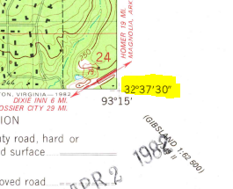
2. Longitude
3. Latitude
4. Graticule
5. Scale
6. None of these
7. How many acres are in a half section?

A 640 B 320 C 160 D 80 E 40

1. What is the elevation of the banks on Bayou Dorcheat in S ½, S1, T19N, R10W

A 150

B 156

C 160

D 170

E None of these

1. This runs through E1/2 of SW1/4, S26, T20N, R10W. What is it?

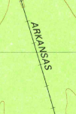

A State line

B Railroad

C Gas pipeline

D Bridge

E None of these

1. When was this map field checked?

A 1976

B 1978

C 1981

D 1983

E None of these

1. What creek is found about ½ mile due west of the shady grove cemetery in S17, T20N, R9W

A Dorcheat

B Caney

C Pipeline

D Fiddler

E None of these

1. What is the contour interval of this map?

A 1 feet

B 2 feet

C 20 feet

D 100 feet

E None of these

1D

2C

3D

4B

5B

6A

7B

8B

9D

10E